EE273 Project Report – Group 20

**“Project S: Command Line Graphical Calculator ”**

**By Thomas Morris (201514719) and Khaled Mohammed (201618237)**

*‘We confirm and declare that this report and the assignment work is entirely the product of our own efforts and we have not used or presented the work of others herein.’*

EEE DEPARTMENT

UNIVERSITY OF STRATHCLYDE

GLASGOW

Table of Contents

1. Introduction 3

2. User Requirement Specification 4

2.1 Functional Specification 5

3. Program Design 7

3.1 EquationSolver Class 8

3.1.1 EquationSolver() 9

3.1.2 DoOperation(string& lhs, char op, string& rhs) 9

3.1.3 CorrectedString(string& arg) 10

3.1.4 RemoveSpaces(string& arg) 10

3.1.5 Parse(string& param) 10

3.1.6 Calculate(vector, vector, string) 10

3.1.7 isSolvable(string eq) 10

3.1.8 StringSolve Functions 11

3.1.9 Search Functions 11

3.1.10 Array Solve functions 11

3.1.11 Discussion of EquationSolver class 12

3.2 EquationElement Class 12

3.2.1 How the EquationElements functions work 13

3.2.2 Discussion of EquationElement class 14

3.3 BarChart Class 14

3.3.1 Functions within BarChart class 15

3.3.2 Discussion of BarChart class 15

3.4 Draw Class 15

3.4.1 Draw Class Functions 16

3.4.2 Draw Class discussion 17

3.5 Main.cpp 17

4. Testing 17

4.1 Trigonometric Function Testing 18

4.1.1 Sine amplitude (#S001) – Sine Amplitude Testing 18

4.1.2 Sin angular velocity(#S002) – Sine with varying expressions inside brackets 19

4.1.3 Sine string parse (#S003) – Unexpected inputs and larger polynomial values 22

4.1.4 Sine with xn #(S004) 23

4.1.5 Cos Amplitude – (#C001) 24

4.1.6 Cos with more complicated expressions – (#C002) 25

4.1.7 Cos with phase shift (#C003) 26

4.1.8 Cos string parse (#C004) 27

4.1.9 Cos with xn (#C005) 28

4.1.10 Cos with constant argument (#C006) 28

4.1.11 Basic Tangent Tests (#T001) 29

4.1.12 Tan with varying velocity – (#T002) 30

4.1.13 Tan Phase Shift – (#T003) 31

5. Discussion of Results and Overall Program Functionality 31

6. Further Work 33

References 33

Appendix A – EquationSolver Class 34

Appendix B – EquationElement Class 52

Appendix C – BarChart Class 56

Appendix D – Draw Class 58

Appendix E 61

Appendix F – Testing 63

Appendix G – User Guide 67

# Introduction

The aim of this report is to detail the planning and procedure which was used to write the program “Command Line Graphical Calculator” using the C++ language. The report will also contain all of the relevant code listings, function descriptions, testing procedures and results as well as an overall description of how well the user requirement specification for the project was met, with a reflection on the limitations of the code and how the program could be improved if more time had been available to the group.

The program specification and user requirement was detailed in the project brief. A summary of the brief is as follows. **[1]**

*“ The aim of the project will be to implement a system where the user can input equations and plot simple representations of data on screen. The user should have the option of visualising boxplots and bar charts. The key challenge will be to parse the strings, involving decisions on operator precedence and having some recursion/looping to use every token in the equation. Some of the suggested classes involved were:*

* *Equation Solver*
* *Equation Element*
* *Plot Area*
* *Plot Axes*
* *Plot Elements*

*The key challenge is to be able to parse equations and dealing with operator precedence to decide in which order to evaluate the string. ”*

As is evident throughout the report, the project was a success as all of the original user specification was met with some additional features added to improve the overall program.

The project was helped by the use of many resources including textbooks, course notes, online lectures, websites and 3rd party code, all of which is credited where approriate. This code for this project was written in C++, a language which had been studied in depth as part of the EE273 class and this project allowed the group to enhance their knowledge of the language and learn other essential programming skills. The project was planned and executed using Object Orientated Programming (OOP). For those readers of this report who are unfamiliar with Object Orientated Programming, OOP allows programmers to work independently of one another and to combine the code they have written in to one final program, with little effort, providing it has been effectively planned. OOP uses classes and objects, where a class creates a new type and an object is an instance of the class **[2]**.

The use of classes in the program made the project much easier to design and implement, as child classes were able to inherit functions and variables from their parent classes, resulting in functions only needing to be defined once. This project report will demonstrate throughout how OOP was essential to the program and successful execution of the project.

# User Requirement Specification

Using the project brief **[1]**, a user requirement specification was written by the group. A URS is a document which is an overall brief of exactly what the user expects the software to be able to do and is therefore the most essential part of the project, as all further actions and planning are based on the URS. The URS can be seen in **Table 1.**

|  |  |
| --- | --- |
| **Table 1. User Requirement Specification** | |
| **Description of the project being developed:** A program which will enable the user to plot simple representations of data, boxplots and bar charts, using the command line as an input. The user will be able to make a choice of the type of visualisation that they want and then enter a string or relevant information via the command line which will be parsed, using operator precedence where necessary to achieve the correct result and then this can be visualised on the screen. | |
| **High level functionalities associated with the application.** | |
| **#1** | The user can choose the type of graph they would like to represent, e.g. boxplot or barchart. |
| **#2** | If boxplot is chosen, the user can choose to enter different types of equation such as polynomial, trigonometric or exponential equations, which can be solved. |
| **#3** | If barchart is chosen, the user can choose how many data entries there are and the relevant size of each of these date entries. |
| **#4** | The program can correctly deal with operator precedence, based on BODMAS. |
| **#5** | The program makes use of OOP, using classes and inheritance so that the program can be easily maintained and updated. |
| **#6** | The visualisation of data is accurate. Each type of data visualisation has its own unique colour when seen on the screen for clarity and aesthetics. |

This URS differs very slightly from the original URS which was written by the group, as initially the group planned to implement an extra feature, a save feature which would enable the user to save the data visualised in the form of a JPEG or other common format, however this feature was deemed unnecessary and as a result of this being an extra feature, was removed from the final URS.

## 2.1 Functional Specification

The URS is a very brief overview of what the program should be able to achieve, however for the functionalities listed to be achieved, they must be planned in more detail. A Functional Specification goes in to more detail as to how the URS will be met. The Functional Specification can be seen in **Table 2.**

|  |  |  |  |  |
| --- | --- | --- | --- | --- |
| **Table 2. Final Functional Specification** | | | | |
| **No.** | **Functionality** | **Description** | **Required inputs** | **Outputs** |
| 1 | Allow user to choose data representation type | The user can use a keyboard input to input a character or number to choose either box plot or bar chart data visualisation. | Keyboard input character or string. | A list of the graphs which can be chosen. |
| 2 | User can choose from a Polynomial, Trigonometric or Logarithmic and Exponential equation to visualise. | The user can enter: Polynomial equations up to and including x3 terms, sin, tan and cos terms and logarithmic and exponential terms. | Relevant variable values. Numbers and characters in the form of a string. | The program will arrange the user input in to a format understood by the program. |
| 3 | User should be able to enter the relevant information for a bar chart. | The user is able to choose how many data entries there are (with a maximum of 8 entries) and the amplitude / value of each of these data entries (with a maximum value of 31 for each entry). | Relevant variable values.  Numbers in the form of characters. | The program will arrange the user input in to a format understood by the program.  Program will show an error if values exceed max values. |
| 4 | Use Operator Precedence when dealing with the string to determine the correct values. | The program uses BODMAS operator precedence to determine which numbers and associated operators should be calculated first. | Previously entered equation data / string. | The final values for each term e.g total numbers for each x3 and constant value. |
| 5. | Plot the relevant graph | The program should plot the data accurately and over a suitable range. Each type of data plot will be a different colour for clarity and as an additional feature which will visually enhance the program. | Data from the EquationElement Class which will enable the equation to be plotted correctly and accurately. | The visualised data, based on the equation and constraints. |

Now that the group had a clear functional requirement specification, the group was able to create a ‘project plan’ so that the project would be completed on time and ensure that each part of the URS had been met, as well as allowing suitable time for testing and alterations to the overall program if necessary.

# Program Design

This section, in combination with the testing and results section, will be make up the main body of the report and will discuss each of the classes and their functions in detail. Each class has its own subsection where the class is discussed in detail, including the planning, how it relates to the URS and functional specification and references to the actual code written for the program. Throughout this section, the unified modelling language is used to visualise the design of the classes and the system as a whole.

The final, high level UML design, omitting the functions at this stage is shown below in **Figure 1**, to illustrate the relationship between classes.

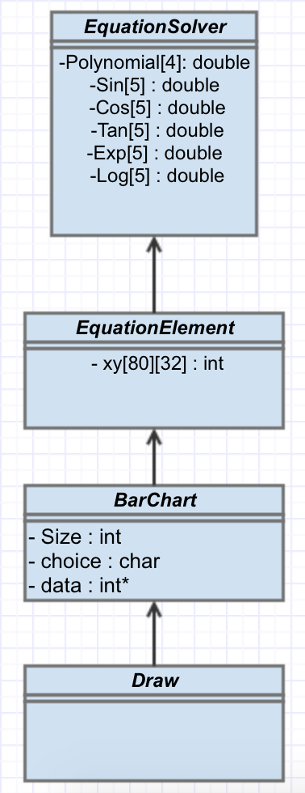

**Figure 1**. Project UML diagram

As can be seen from **Figure 1**, there are 4 classes in the project, which are all child classes of the EquationSolver parent class. The hierarchy in the diagram shows in which order the classes inherit from one another, e.g. EquationElement is a chid of EquationSolver and BarChart is a child class of EquationElement.

## EquationSolver Class

The EquationSolver class is the parent class from which the EquationElement class is a child. This class is used to define functions for parsing strings, dealing with operator precedence to calculate actual values and assigning protected variables, arrays, which store the values of the numerical value associated with x3, x2,x and +c for each possible string term. These arrays can then be accessed by the EquationElement class in order to calculate actual values for the equation. The EquationSolver class must correctly determine the numerical value associated with x3, x2,x and +c for each possible string term.

Initial Research was carried out using the internet to research string parsing and how to correctly deal with operator precedence and it was discovered that an online website which shared open source code contained an existing program which would be useful for this project. The existing program was called “Simple Equation Solver in C++” and was a program which had been shared after being adapted from Java **[3].** The code was written and shared by Alex Edwards in 2009 and the website is a community forum where people share knowledge and code and the code shared is free to use for anyone as long as it is not for commercial gain, therefore it was appropriate to use in this project. Code from this program was adapted and used as part of this project, specifically the EquationSolver class and it is the only time any external code is used throughout the project.

The external code initially contained over 470 lines of code, however the majority of this code was irrelevant to this project and the total amount of code used in this project from this external source is 180 lines. The external code was a program which was able to take an input string containing numbers and operators and return a final number. This basic functionality was useful as, although this program was unable to deal with any characters and terms such as x3 or sin, it was able to correctly deal with operator precedence using vectors and the math.h library. This allowed strings to be correcly parsed and the relevant strings associated with each terms to be passed to these functions which can solve based on operator precedence.

The EquationSolver.hpp file can be seen in A**ppendix A, Figure 1.**

The UML diagram for the EquationSolver class can be seen in **Figure 2.** All of the UML diagrams were made using free to use online software from Creately.com **[4].**

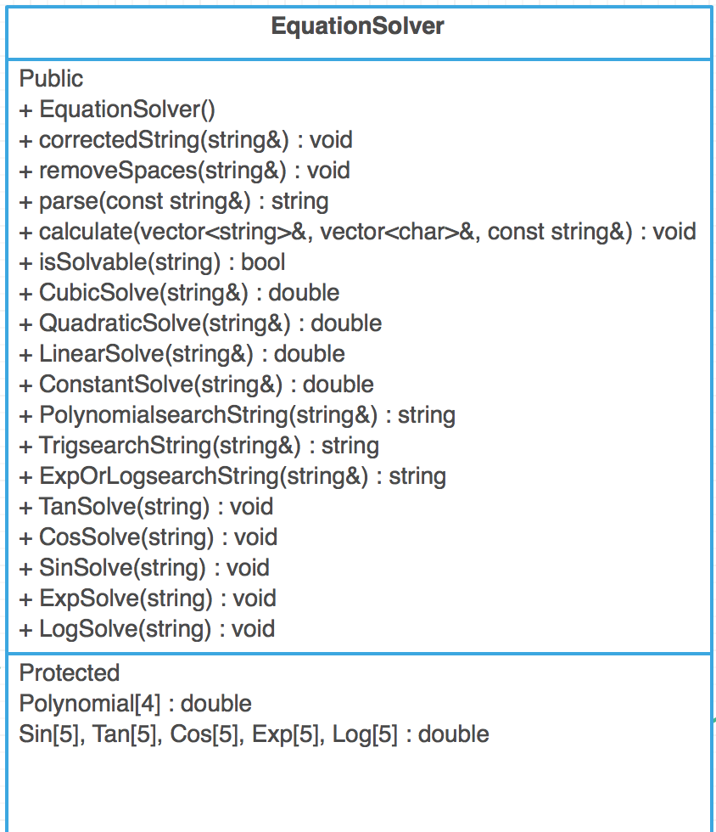

**Figure 2.** UML diagram for EquationSolver Class

### EquationSolver()

The constructor for this class initialises all of the array values, to 0 to ensure there is no unexpected data in the arrays. The constructor can be seen in A**ppendix A, Figure 2.**

### DoOperation(string& lhs, char op, string& rhs)

This class uses the math.h library to calculate the numerical values passed to it, using the values from a numbers and operators vector. The function returns a numerical value converted to a string, for the purposes of the use in other functions. The function makes use of a switch statement to determine which math.h function to call, before evaluating the numerical values either side of the operator with the operator to calculate a final value. This function is called by the calculate (vector<string>& totalNumbers, vector<char>& totalOperations,const string& arg) function.

This function can be seen in A**ppendix A, Figure 3.**

### CorrectedString(string& arg)

This is a very simple function which removes the external brackets from the argument string and returns the ‘corrected’ string.

This function can be seen in A**ppendix A, Figure 4.**

### RemoveSpaces(string& arg)

This is a very simple function which removes any spaces from the argument string and returns the ‘corrected’ string.

This function can be seen in A**ppendix A, Figure 5.**

### Parse(string& param)

This is the longest and arguably most important function within the class. This function calls several other functions within the class. The purpose of this function is to parse the string which is passed to it and put all the numbers within the string in to a vector and all of the operators within the string in to a separate vector, so that these can be calculated. The function deals with operator precedence, as it firstly finds all terms with brackets and adds those to the final string before calling the calculate(vector, vector, string) function.

This function is used once the terms have been parsed and sorted by other functions, e.g. once a separate function has been able to group all of the x2 terms so that the string passed to it is (1+3/2-(3*5)) and the function is able to return a value for this.

This function can be seen in A**ppendix A, Figure 6.**

### Calculate(vector, vector, string)

This function is used to call the previously mentioned doOperation function, with the relevant numbers from their vectors and the operator.

This function reduces the vector sizes by 1 each time the doOperation function is called and then re-sizes the vectors until all of the values have been used.

This function can be seen in A**ppendix A, Figure 7.**

### isSolvable(string eq)

This is a function which checks if, in theory, the string can be solved. It checks that the number of open brackets is equal to the number of closed brackets, whether each ‘x’ character has a numerical value associated with it and if the ‘power’ operator has a number each side of it. It also ensures that the power of each x value entered does not exceed the maximum the program is designed to work with, e.g. x3 is the maximum value it will allow.

It returns a boolean value to determine whether the string passed was deemed solvable or not.

This function can be seen in A**ppendix A, Figure 8.**

### StringSolve Functions

There are 4 functions which are all very similar and therefore they can all be described in this section, they are the Cubic, Quadratic, linear and constant solve functions. These functions all take a string in the form (abc)x3 for example and extract the string in brackets before the relevant x term they are looking for before passing this to the parse() function. Then they erase the string that was used for calcuation and pass the rest of the string to the next function.

These function can be seen in A**ppendix A, Figure 9.**

### Search Functions

There are 3 functions which are very similar in the way that they work, the polynomial, trigonometric and exporlog search functions. These functions all find the relevant term within the string before extracting the characters associated with that term from the string, e.g tan search will take tan(3x+4+2x) and pass the value (3x+4+2x) to the polynomial search function which will return the string (5x+2).

These are essential for sorting the string to be calculated by other functions.

These functions can be seen in A**ppendix A, Figure 10.**

### Array Solve functions

These functions call the relevant stringSolve functions and store the result of the function call in the array value associated with the function. This is the final function called which sets the array values so that these can be used by the EquationElement class.

These functions are all very similar however they each have a different array that they are associated with and therefore code repetition was necessary.

These functions can be seen in A**ppendix A, Figure 11.**

### Discussion of EquationSolver class

Now that all of the individual functions have been discussed and described, it can be discussed how the EquationSolver class is able to meet the user requirement specification.

The EquationSolver class allows the user to enter a wide range of equations using strings, including polynomial equations up to and including x3, trigonometric terms, logarithmic and exponential terms which can be solved. The class meets the URS as these terms are evaluated correctly using BODMAS, before allowing each term to be solved and placed in an arry variable, which is a protected member of the EquationSolver class. For example, if the user entered the following:

(1+2)x^2+(1*4)x + 3x^3 + 7

The class would be able to store the values as follows.

PolynomialArray[number of x^3,number of x^2, number of x, number of constants]

Giving [3,3,4,7] in the Polynomial array.

This is then essential for the EquationElement class which can use these values to calculate x and y values for the equation which has been entered.

Therefore the URS is met by this class because it has allowed a string equation to be entered, it is then sorted by parsing the string and solved based on operator precedence, before allowing arrays storing relevant sorted and calculated data to be inherited by a child class.

## EquationElement Class

The EquationElement class is the child class of the EquationSolver class. The aim of this class is to calculate actual values of the function using the values from the equation arrays which have been given values by the EquationSolver class. This allows the program to determine if the coordinates are within range and able to be plotted on the screen, as the screen only has a limited range. It also allows the function to be visualised with actual coordinates.

The class has 6 functions all of which are very similar, an example of how the functions work which will be shown in section 4.2.1. The UML diagram of the EquationElement class can be seen in **Figure 2.**

The header file and subsequent code for the EquationElement class can be seen in **Appendix B.**

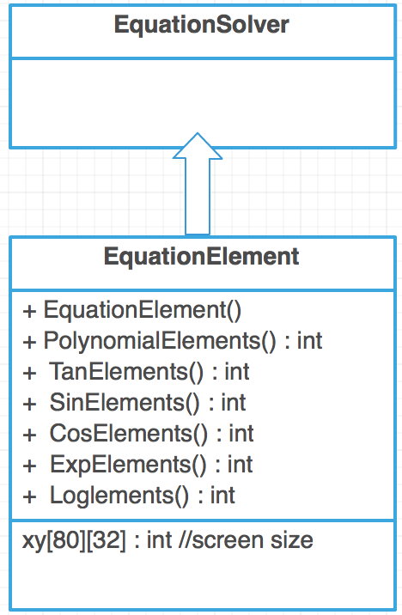

**Figure 2.** UML diagram for EquationElement class

### How the EquationElements functions work

As previously mentioned, all of the functions within this class work almost identically, with each using the math.h library to calculate y values for each x value.

For example, using the TanElements() function to demonstrate. The protected Tan[5] array has been inherited by the class and the format of the array is:

[(0) Amplitude, (1) No. of x3, (2) No. of x2, (3) No. of x, (4) constant]

Therefore using a for loop to give x-values, the y values can be calculated as follows:

Total = Tan[1] * (x value to the power 3) – this gives the x3 value

Total += Tan[2] * (x value to the power 2) – this gives the x2 value added to the x3

Total += Tan[3] * (x value ) – this gives the x value added to the x3 and the x2 total

Total += Tan[4] – this gives the constant value added to the total

Total = Tan[0] * Total – multiplies the total by the function amplitude

Therefore this total can be saved as a y coordinate for each x coordinate.

It then has to be determined whether the y coordinate is within range of the screen, which due to the size can only take values from 0-32 and if the coordinate is within this range, the xy[][] array value is set to ‘1’ for these coordinates, which signifies that a point is to be plotted on the screen at this point. This double dimensional array is inherited by the Barchart() and draw() class.

The function returns an integer, which is simply a colour code which is used to show the function in colour on the screen, using windows.h libarary.

These functions can be seen in **Appendix B** after **figure 1.**

### Discussion of EquationElement class

As has been shown throughout this section, the EquationElement class met the URS and functional specification by determining coordinates for the function, allowing the shape and colour of the function to be determined, as well as populating a 2-dimensional array with values of either 1 or 0 which will be used by the Draw class to determine how to visualise the data.

## BarChart Class

This class was designed to meet the URS by allowing the user to enter data necessary to visualise a bar chart. This relatively simple class is a child class of the EquationElement class, allowing it to inherit the protected variable of the two dimensional xy array which determines where points will be plotted in the draw class.

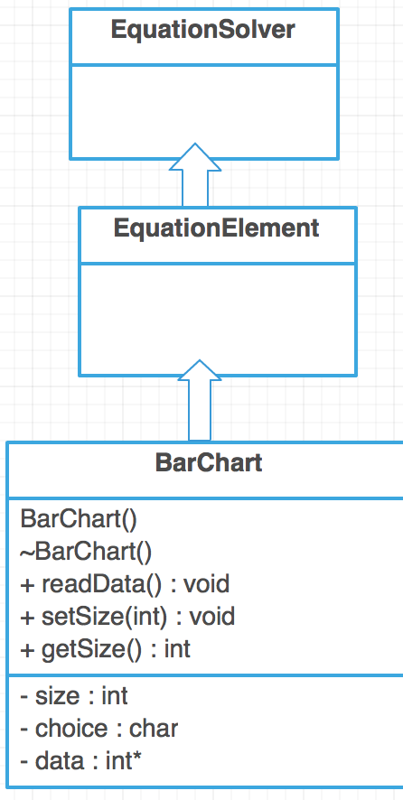The header file for the class can be seen in **Appendix C, Figure 1.** The UML diagram for the class can be seen in **Figure 3.**

**Figure 3.** BarChart UML diagram

### Functions within BarChart class

The BarChart class has several relatively simple functions, which allow the user to enter the number of entries to be visualised, there are a maximum of 8 entries as a result of limited screen console size, therefore the maximum value that can be chosen is 8.

Because the number of entries and the size of each data entry is unknown, an integer pointer must be used to allow the size of the data variable to change and also the size of the array used to hold the data entries must be dynamically allocated, using the ‘new’ command.

The functions allow basic data input to determine the variables necessary and make use of the inherited double dimensional xy array to populate the array with 1s and 0s where necessary to determine which points on the screen will be plotted in the draw class.

The destructor deletes the pointer data, freeing up the memory.

The various functions can be seen in **Appendix C.** With comments and explanations to explain each function.

### Discussion of BarChart class

As has been demonstrated in this section of the report, the BarChart class meets the URS by allowing the user to visualise data which is in the form of a bar chart. It also met the criteria by using OOP to inherit a two dimensional array, meaning this variable did not have to be redefined, saving memory.

## Draw Class

The draw class is a child class of the BarChart class, which allows it to inherit all of the public functions and protected variables from all of the classes defined for the program. The draw class uses the two dimensional xy array to visualise data on the screen, meeting the URS by plotting accurate data quickly.

The UML diagram for the Draw Class can be seen in **Figure 4.** The header file for the draw class can be seen in **Appendix D, Figure 1.**

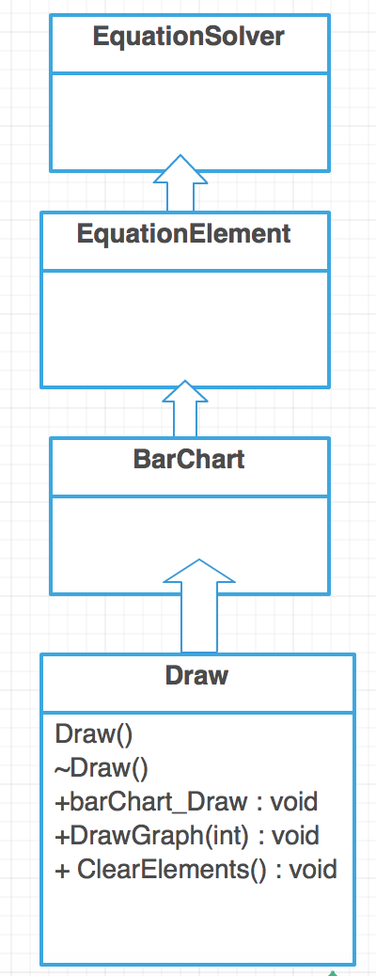

**Figure 4.** Draw Class UML

### Draw Class Functions

As previously mentioned in this section, the draw class has functions which allow the data to be visualised on the screen. The draw class uses the inherited protected variable, xy, the two dimensional array which has been populated with 1s or 0s as appropriate, to determine whether to plot coordinate points on the screen.

The draw class uses for loops to plot axis on the screen console and for every value of ‘1’ in the array will plot a point using a chosen character, the ‘*’ character on the screen. This is in the DrawGraph function and it will visualise the data as different colours for each function type.

The barChart_draw function draws the bar chart on the screen console, again using the xy array it has inherited.

After each time the draw class’ functions are used, the elements in the xy array are cleared so that another function can be drawn using the program.

The functions within the Draw class can be seen in **Appendix D.**

### Draw Class discussion

As has been discussed in this section, the draw class meets the URS by allowing the data from the function to be visualised on the screen console, completing the objective of the program. It does this using OOP and class inheritance to achieve the outcome.

## Main.cpp

The main.cpp is the file which links all of the classes together in one file and provides the user with a basic menu, allowing them to give the program the necessary input to determine which functions to call. The main allows the user to choose from a bar chart or a graphical data representation, before allowing the user to then enter the data needed to allow the program to provide data visualisation.

The main.cpp consists of simple loops and comparisons to determine which functions to call. This allows the URS to be met and the program is complete and must now be tested.

The code from main.cpp can be seen in **Appendix E.**

# Testing

In order to ensure that the program works as expected and does not crash, if the user enters unexpected data for example, it is important that it is thoroughly tested and this section will detail all of the testing inputs and outputs, demonstrating that the code worked as expected and was able to meet the URS.

As the code was being written, it was written in such a way as to attempt to prevent the majority of common errors from occurring. Writing code in this way saves time at the end of the project trying to adjust large amounts of code to prevent errors and this was extremely useful to the project. The members of the group planned all of the code in advance and this also contributed to making the code much less likely to have errors.

A large number of tests were carried out to determine the program worked as expected. A table detailing all of the tests and expected outputs can be seen in **Appendix F.** As can be seen in **Appendix F**, each set of tests has a unique ID. Each ‘1’ in the expected results column signifies a successful test result.

The results of these tests can be seen in this section of the report. There were no unexpected outputs during the testing stage of the project, as a result of the code being written in such a way as to prevent the majority of common errors.

Examples of expected outputs can be seen where the output is more complicated and these were generated using free to use online software, ‘Desmos Graphing Calculator’. **[5]**

## Trigonometric Function Testing

### 4.1.1 Sine amplitude (#S001) – Sine Amplitude Testing



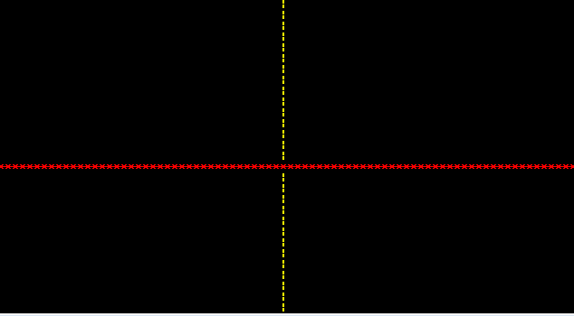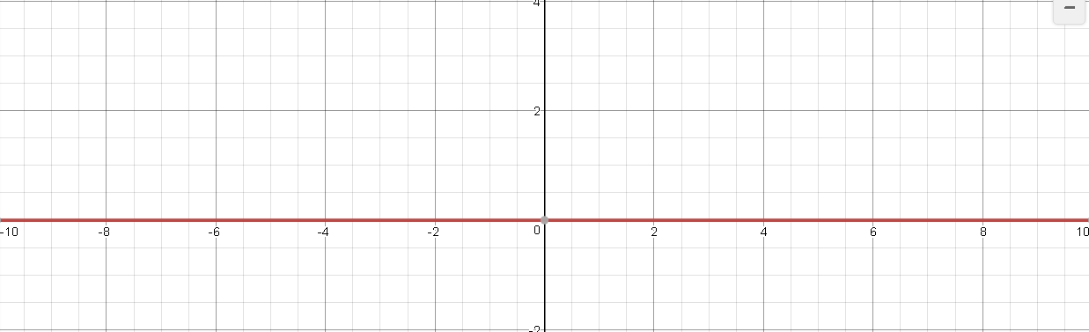

**Figure 5(a).** 0sin(1x)

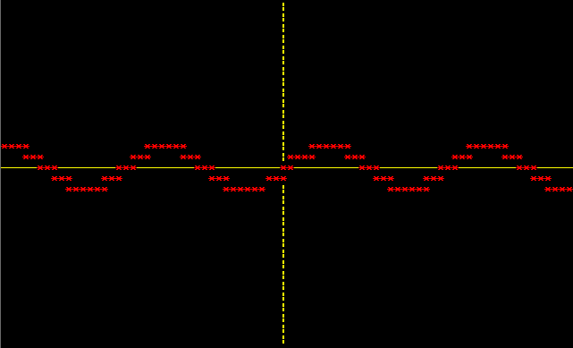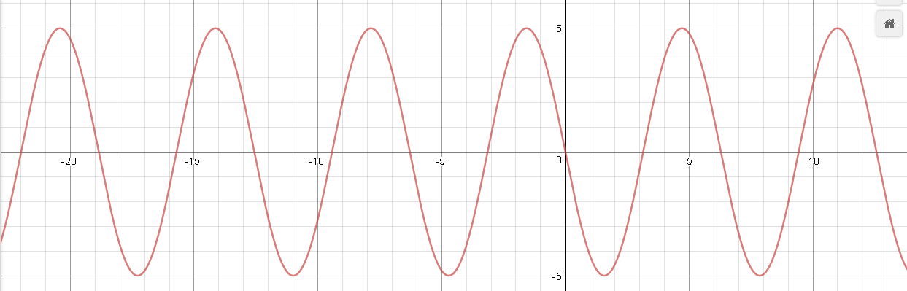

**Figure 5(b).** 0.5sin(1x)

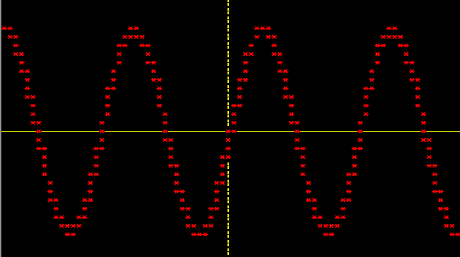



**Figure 5(c).** 1000sin(1x)

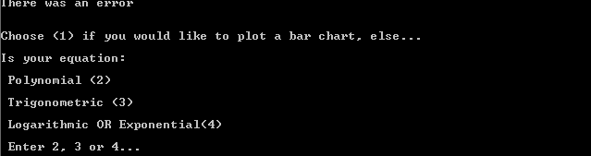

**Figure 5(d).** x+1sin(2x)

This test returned an error as expected, as trigonmetric functions must contain one trigonmetric term with an expression in brackets only.

### Sin angular velocity(#S002) – Sine with varying expressions inside brackets



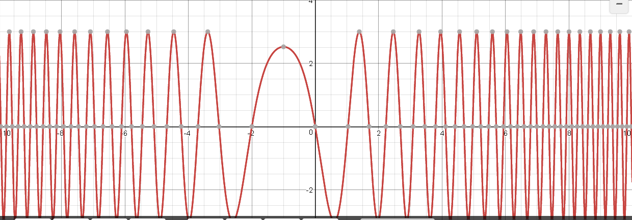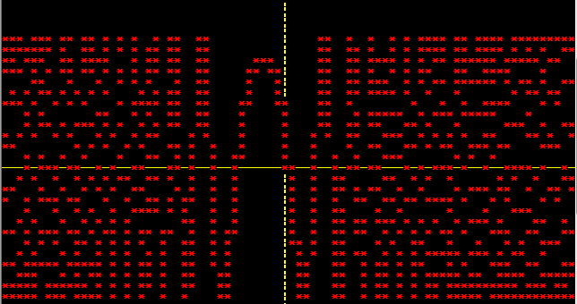

**Figure 6(a).** 3sin(1x2 +2x+pi)

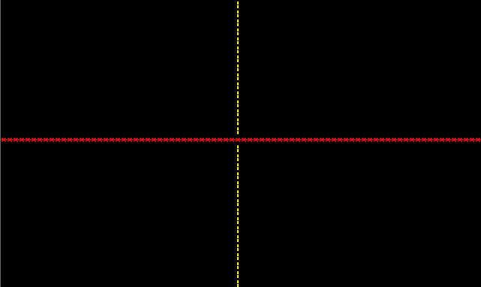

**Figure 6(b).** 3sin(0x+pi)

This function does not have any y values > 0 due to the ‘0x’.



**Figure 6(c).** 3sin(0+0)



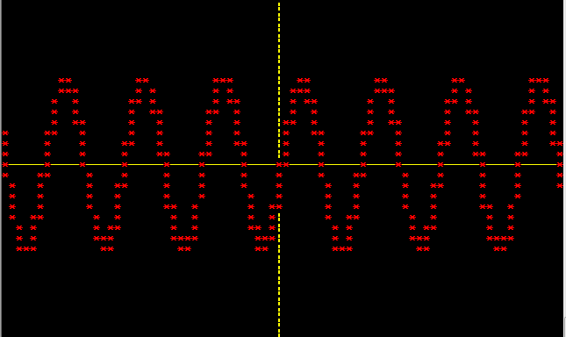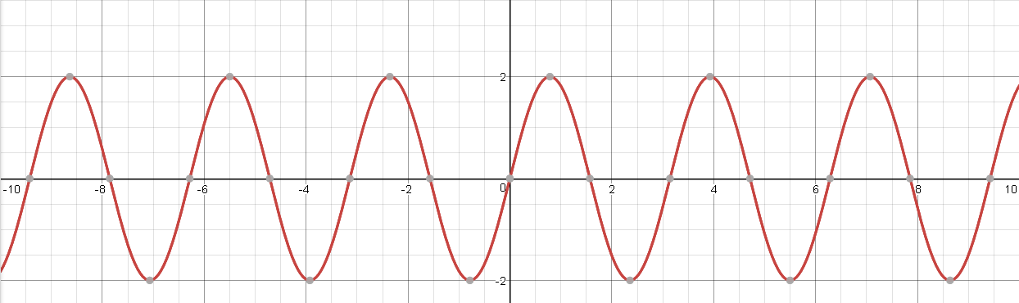

**Figure 6(d).** 2sin(2x+0)



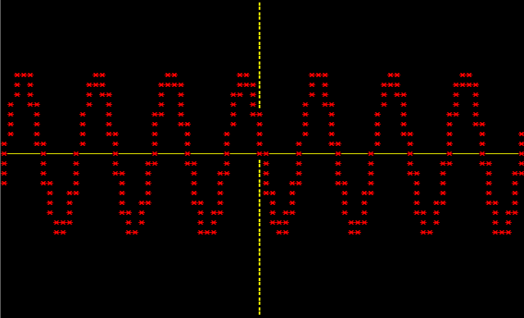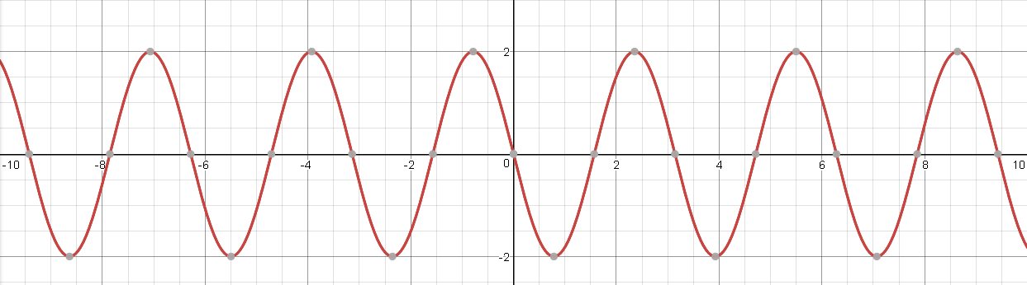

**Figure 6(e).** 2sin(2x+pi)

As can be seen, the phase shift is working as expected.



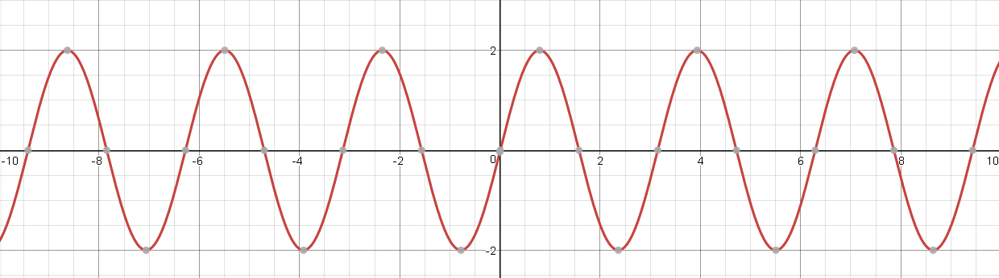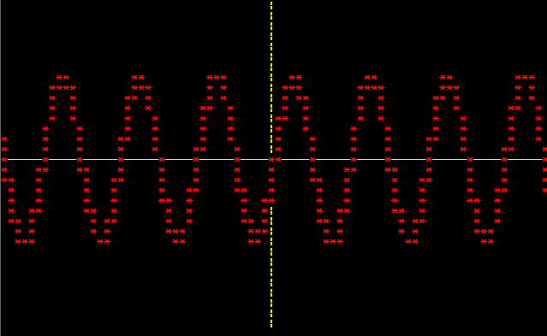

**Figure 6(f).** 2sin(2x+10pi)

As can be seen, a larger phase shift also produced the expected output.

### Sine string parse (#S003) – Unexpected inputs and larger polynomial values



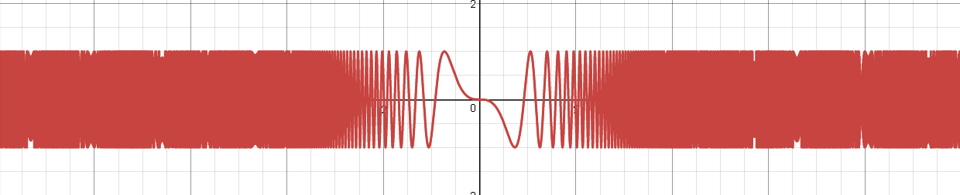

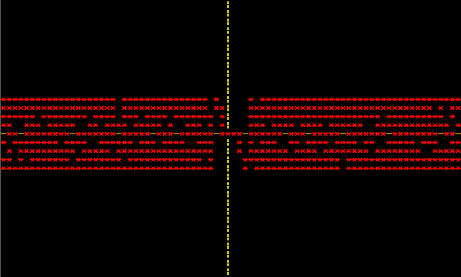

**Figure 7(a).** sin(4x3 + pi)

As can be seen, the output is as expected with some distortion due to limited screen size.





**Figure 7(b).** sin(4x3 + pi

Missing closing bracket returned an error as expected.





**Figure 7(c).** sin4x3 + pi)

Missing opening bracket returned an error as expected.





**Figure 7(d).** siN(4x3 + pi)

Program successfully converts upper case to lower case before parsing, resulting in correct output.





**Figure 7(d).** siN(4x3 + &pi)

Program successfully detects unexpected character and returns an error.

### Sine with xn #(S004)







**Figure 8(a).** xn > 3 or xn < 1

Program successfully detects that xn should be between 1 and 3 and returns an error message to the user.

### Cos Amplitude – (#C001)

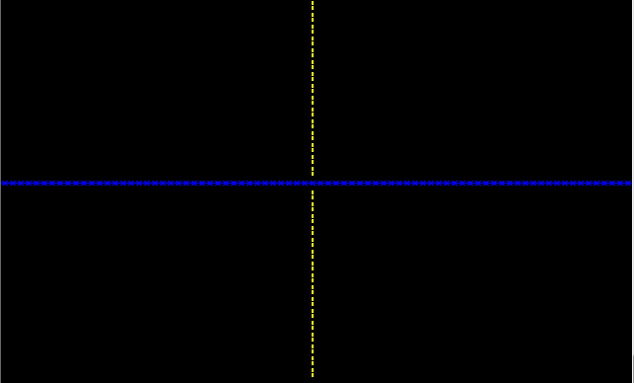



**Figure 9(a).** cos with amplitude of 0

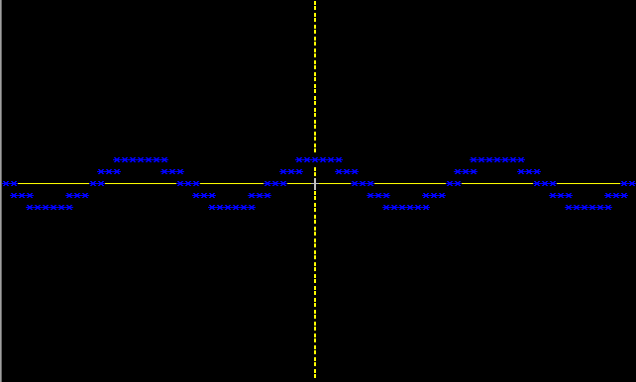

**Figure 9(b).** cos with amplitude of 0.5

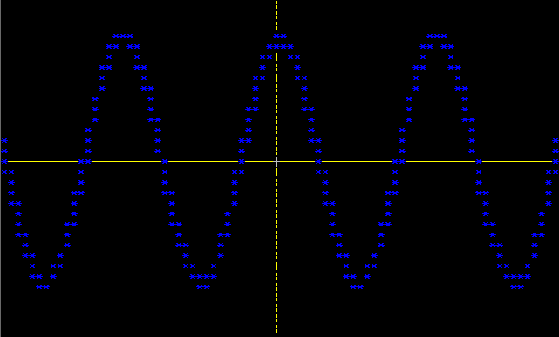

**Figure 9(b).** cos with amplitude of 1000

### Cos with more complicated expressions – (#C002)



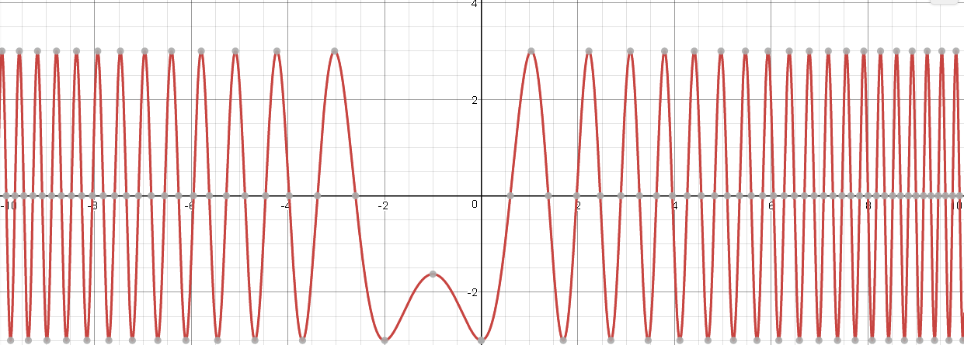

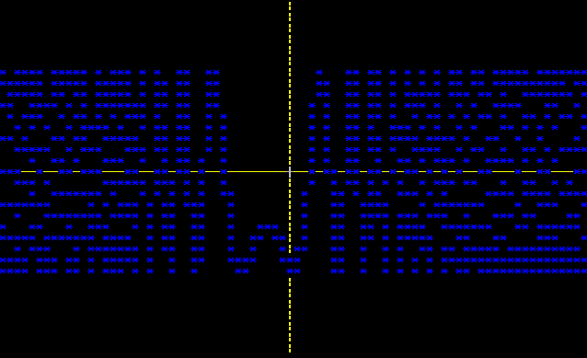

**Figure 10(a).** 3cos(1x^2+2x+pi)

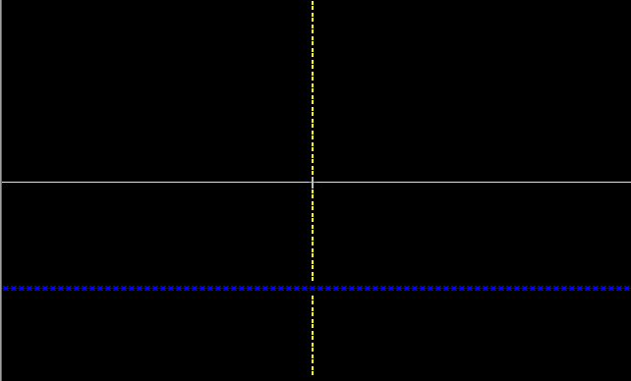



**Figure 10(b).** 3cos(pi)

### Cos with phase shift (#C003)

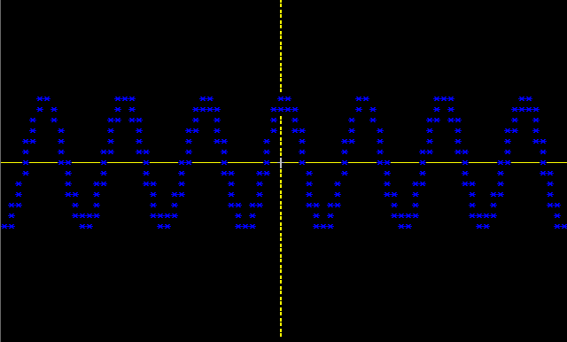



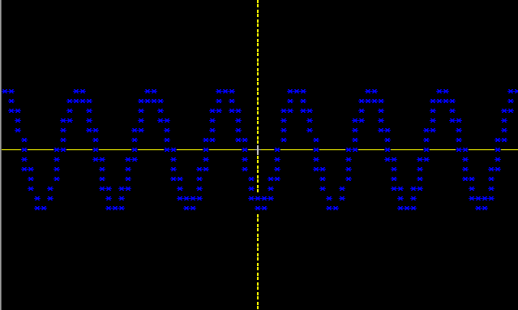**Figure 11(a).** 2cos(2x+0)



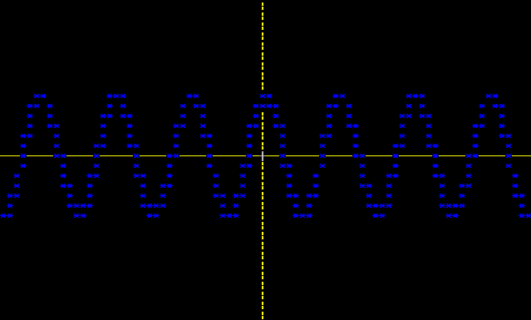**Figure 11(b).** 2cos(2x+pi)

**Figure 11(c).** 2cos(2x+10pi)

### Cos string parse (#C004)



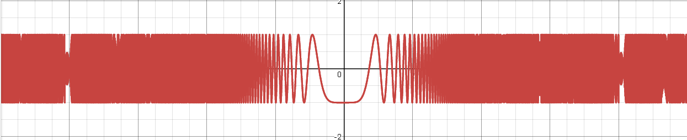

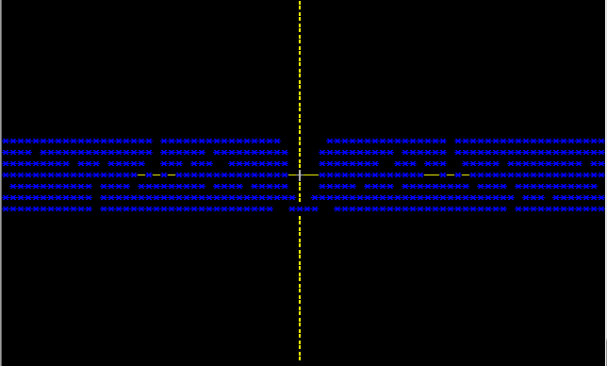

**Figure 12(a).** Cos with missing amplitude

If there is no specified amplitude, the function will assume an amplitude of 1.







**Figure 12(b).** Cos with bracket errors or unexpected characters

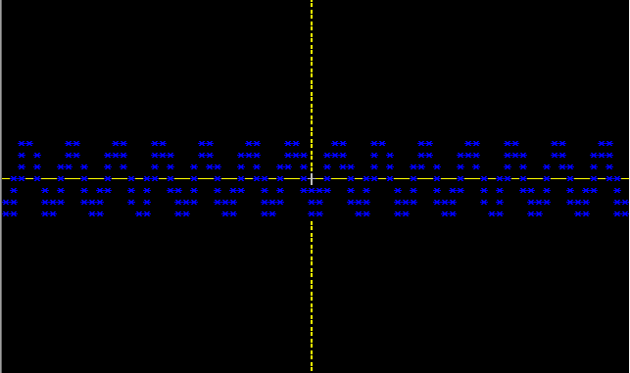



**Figure 12(c).** Cos with capital letters

### Cos with xn (#C005)



**Figure 13(a).** Cos with xn outside range

Program successfully detects that xn should be between 1 and 3 and returns an error message to the user.

### Cos with constant argument (#C006)

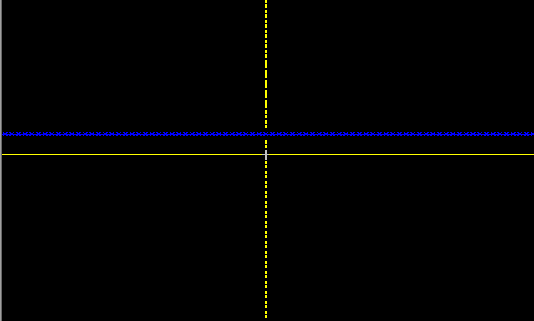



**Figure 14(a).** Cos with constant argument





**Figure 14(b).** Cos with constant argument of 0

### Basic Tangent Tests (#T001)

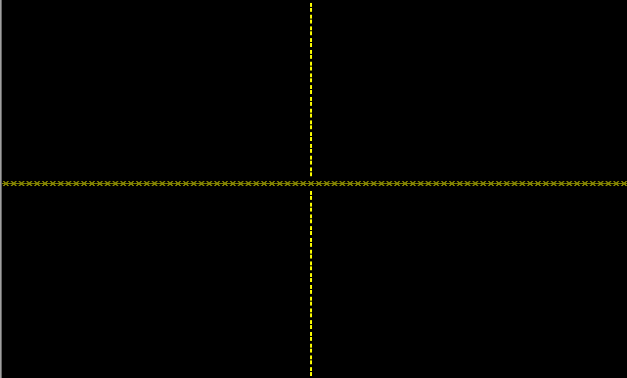



**Figure 15(a).** Tan with amplitude of 0



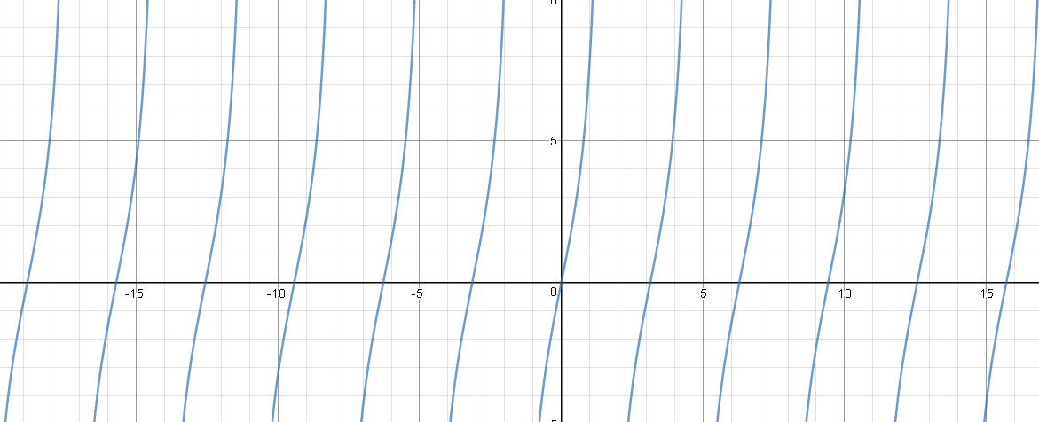

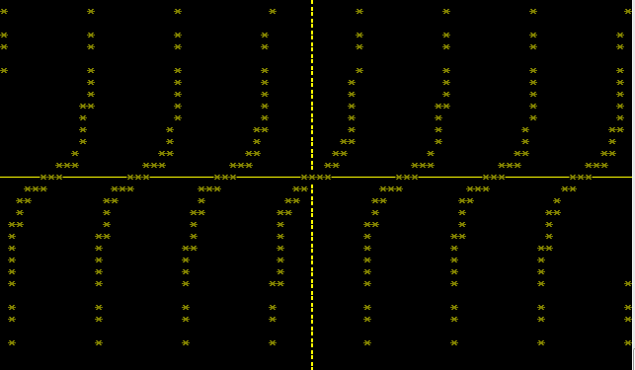

**Figure 15(b).** Tan with amplitude of 0.5

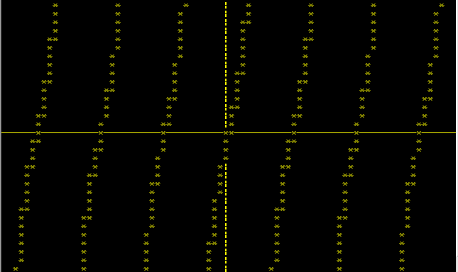



**Figure 15(c).** Tan with amplitude of 1000



**Figure 15(d).** Tan with amplitude as function of x

### Tan with varying velocity – (#T002)



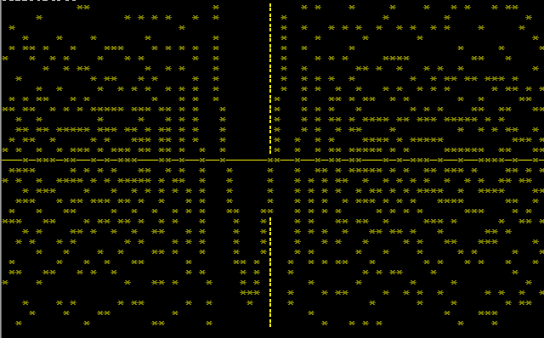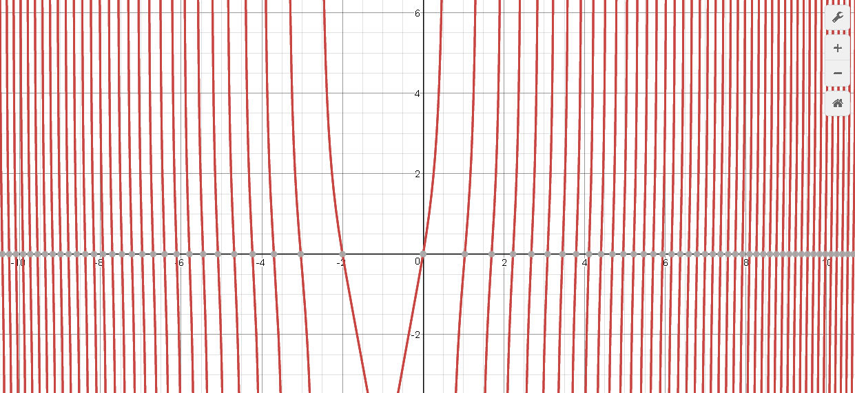

**Figure 16(a).** Tan with amplitude and polynomial expression

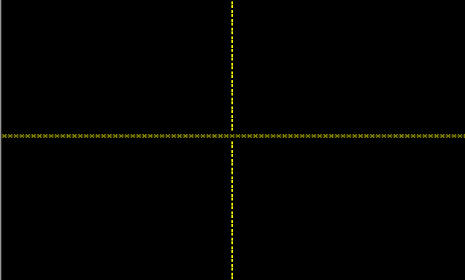





**Figure 16(b).** Tan with constant phase shift and 0 expression

### Tan Phase Shift – (#T003)

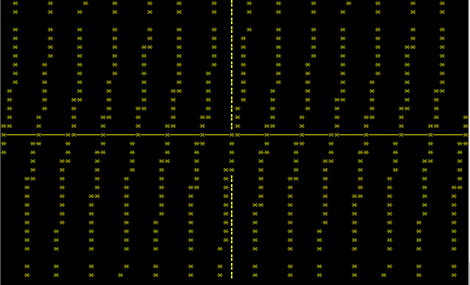

### 

**Figure 17(a).** Tan with phase shift of pi





**Figure 17(b).** Tan with phase shift of 10 pi

### Tan string parse – (#T004)





**Figure 18(a).** Tan with missing brackets or unexpected characters

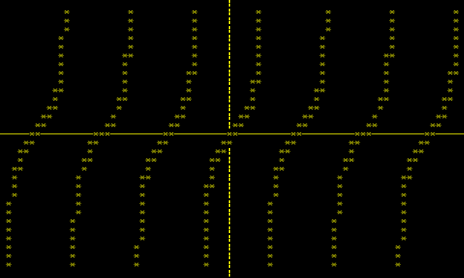



**Figure 18(b).** Tan with capital letters in term

### Tan with xn – (#T006)





**Figure 18(b).** Tan with xn oustide of range

## Polynomial Testing

### 4.2.1 Polynomial with xn outside range – (#P001)







**Figure 19(a).** Polynomial with xn oustide of range

### Polynomial with different coefficients - (#P002)

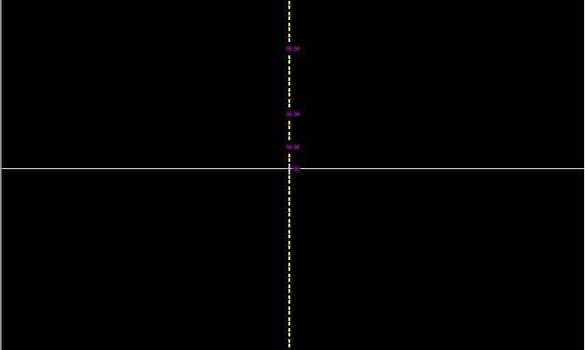



**Figure 20(a).** Polynomial with large coefficient

As can be seen, a very large coefficient does not generate an error however only a few points are plotted, due to the limited scaling abilty of the program for polynomial functions.

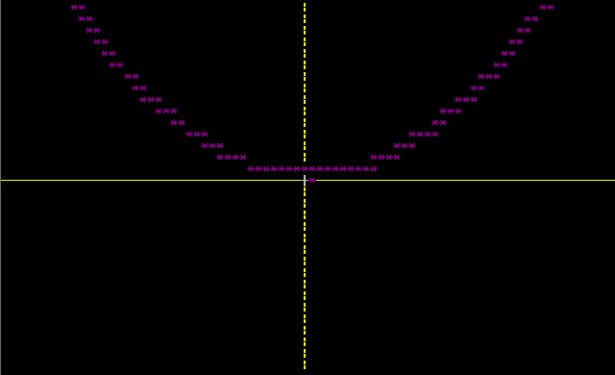



**Figure 20(b).** Polynomial with small coefficient

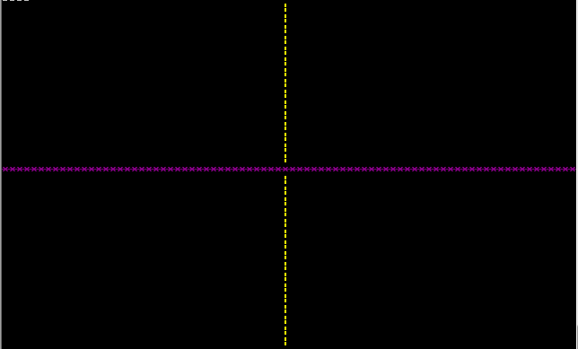



**Figure 20(c).** Polynomial with 0 coefficient



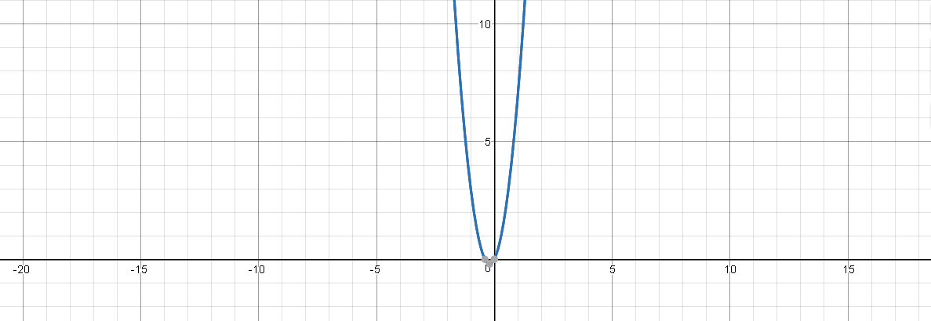

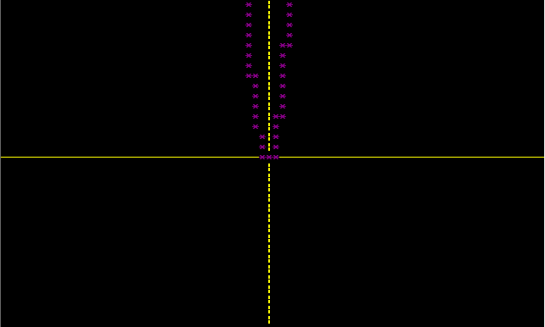

**Figure 20(d).** Polynomial with coefficient in brackets



**Figure 20(e).** Coefficient of x within bracket

An error message is returned as the program is unable to determine xn * xn calculations and therefore x^2 can not be multiplied by x^3.

### Polynomial with only a constant - (#P003)



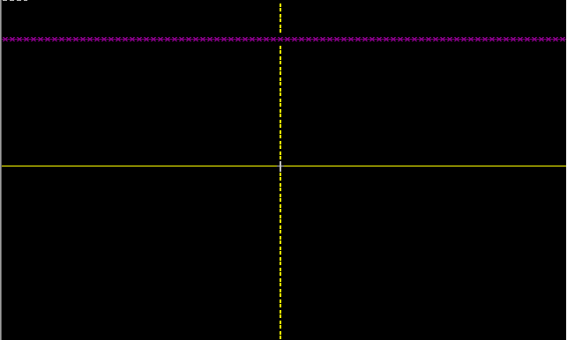

**Figure 20(f).** Constant value only

### Polynomial String Parsing – (#P004)







**Figure 21(a).** Polynomial string missing brackets or with unexpected characters



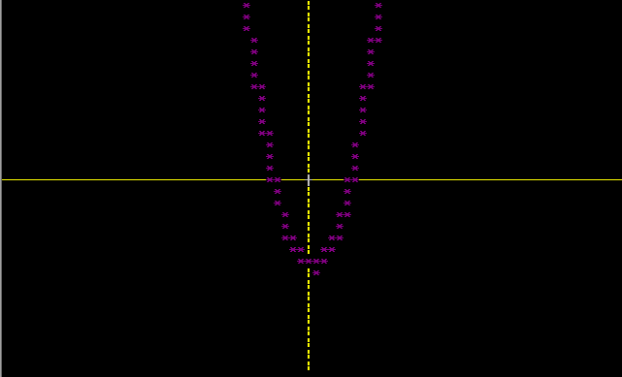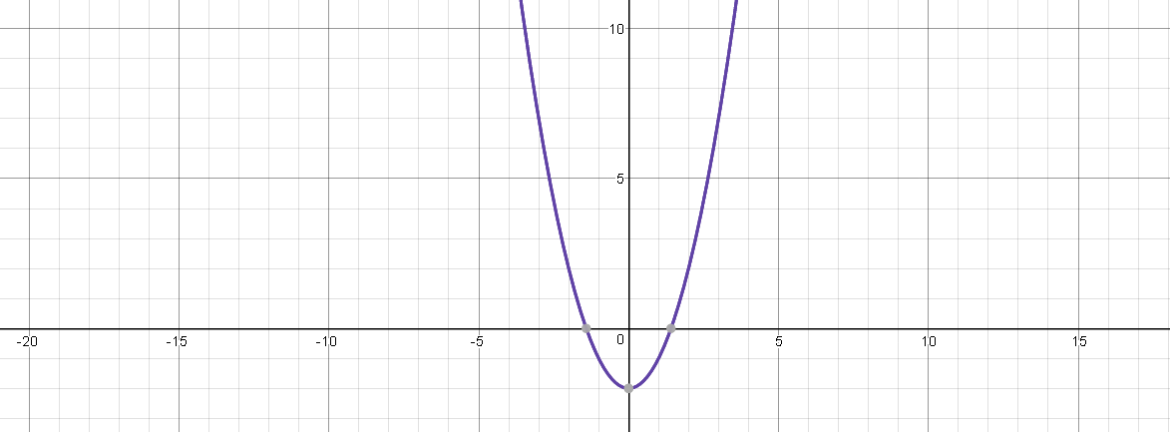

**Figure 21(b).** Polynomial with capital letters in string



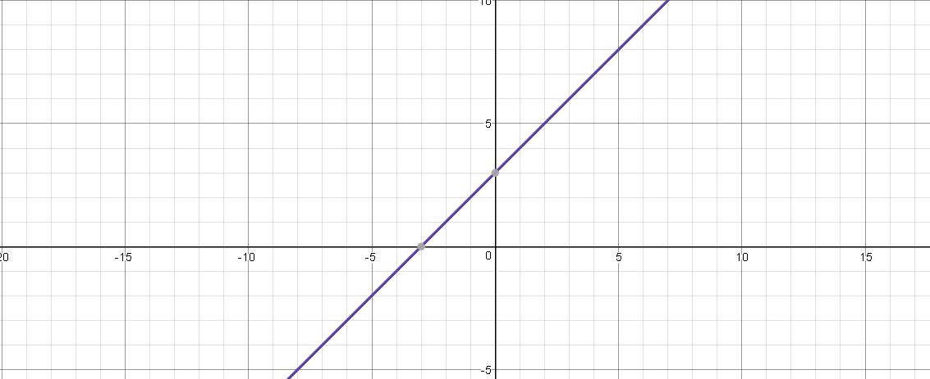

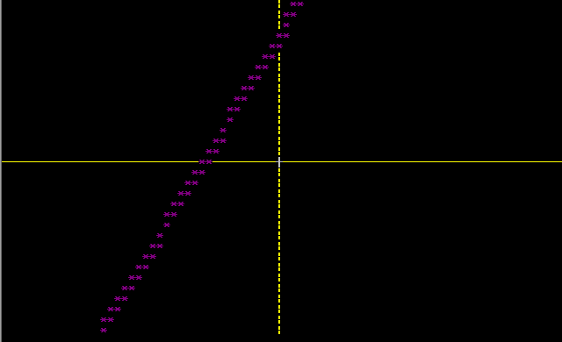

**Figure 21(c).** Polynomial with spaces in string



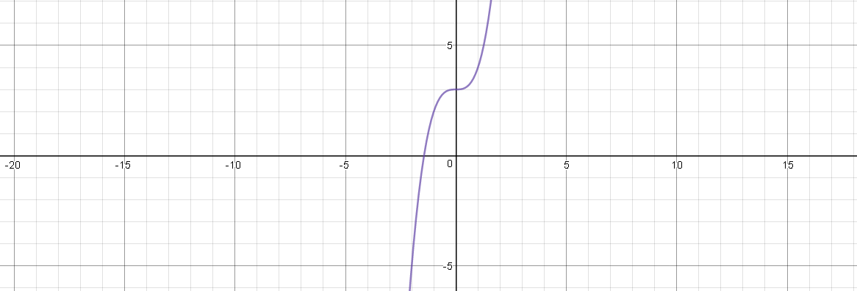

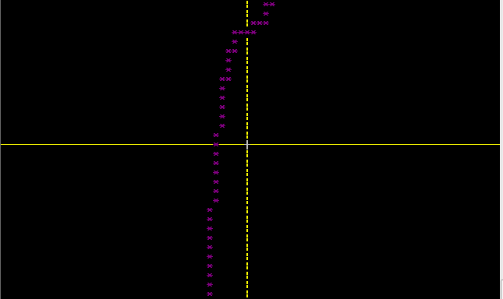

**Figure 21(d).** Polynomial with no brackets and x3

### **Operator precedence (#P005 )**

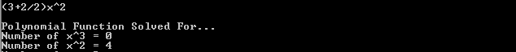

**Figure 22(a).** Operator Predence

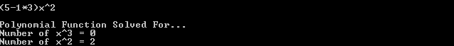Program correctly carried out division first before addition.

**Figure 22(b).** Operator Predence

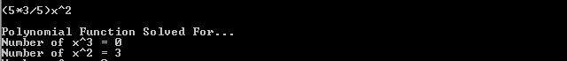Program correctly carried out multiplication before subtraction.

**Figure 22(c).** Operator Predence

Program correcly carried out division before multiplication as in BODMAS.

## 4.3 Exponential and Logarithmic Function Testing

### 4.3.1 Basic Exponent Testing – (#E001)

As all functions that the program uses to plot an exponential or logarithmic graph have been tested thoroughly it is only neccesarry to show basic testing for strings being entered containing exponential or logarithmic terms, once option ‘4’ has been chosen at the main menu.

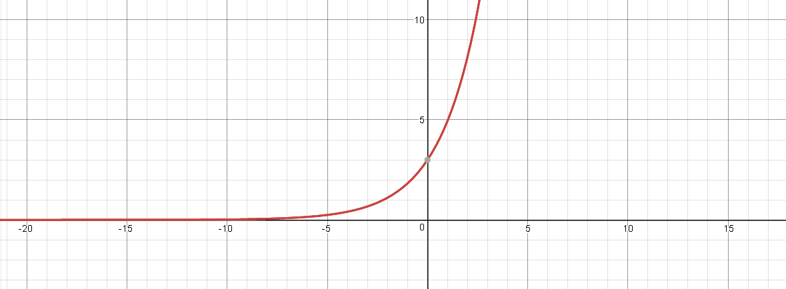

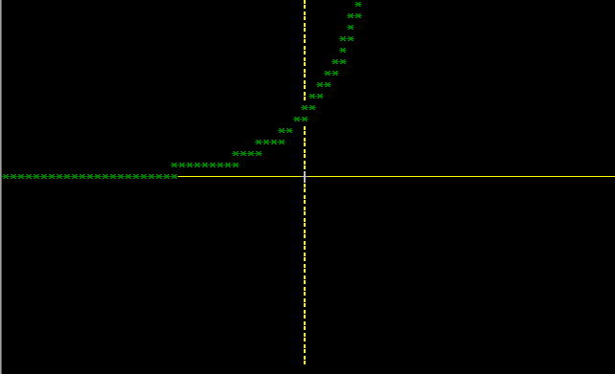



**Figure 23(a).** Exponential Function



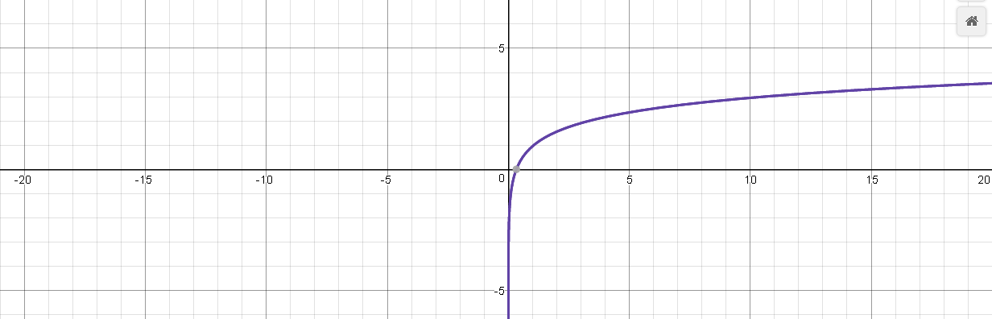

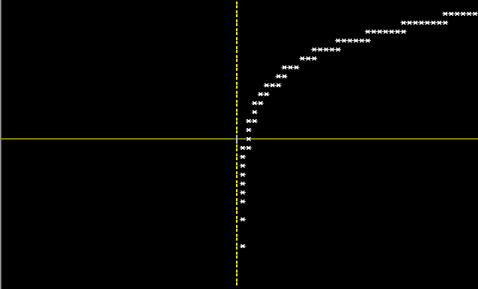

**Figure 23(b).** Logarithmic Function

## Bar Chart Testing

### 4.3.1 Number of data in range - (#B001)

### Amplitude of data entries – (#B002)

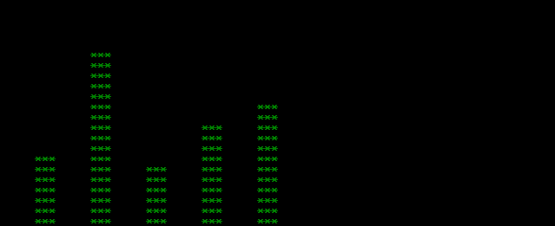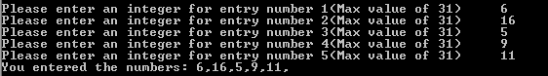

**Figure 24(x).** Bar Chart data entries





**Figure 24(x).** Bar Chart data entries greater than maximum

As can be seen, if a value greater than the max value is entered, the entry is set to the maximum value of 31 by default.

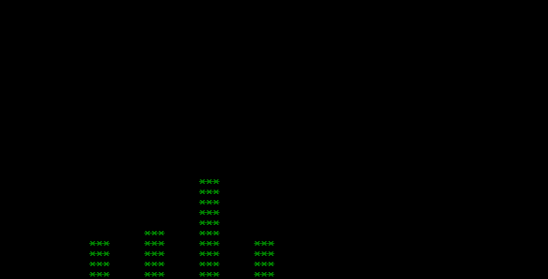

**Figure 24(x).** Bar Chart data entries including 0

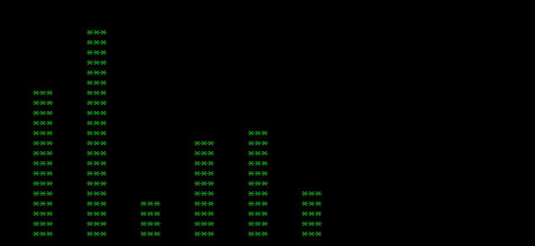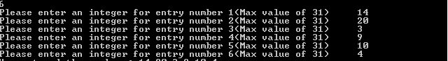

**Figure 24(x).** Bar Chart data across amplitude range

# Discussion of Results and Overall Program Functionality

As can be seen throughout section 4, testing, the program worked as expected throughout testing and the user requirement specification was fully met. This demonstrates that the project was a success, with all of the objectives within the group also being met in order to achieve the final program.

There are limitations to the project, meaning the project could be improved. Some examples of simple limitations are the fixed console size, if the user chooses to re-size the console on Visual Studio, the data visualisation remains on a fixed point on the screen and does not get any larger. There are other simple limitations such as the limited number of data entries, 8, which the Bar Chart can take and the maximum amplitude, 32, of these entries, again this is due to the fixed console size, as the console parameters which the program was written and designed to operate with are the default Microsoft Visual Studio 2013 console sizes, meaning that the program may also be initially unsuitable for use with other compilers. However, the program could be edited to work with a new complier by changing some of the values in the loops for example so that it can work with consoles of different dimensions.

The limited console size also means that some functions look slightly distorted when plotted on the screen, such as some tan graphs including x3 terms for example, as can be seen in the testing and results section of the report. It can therefore be concluded that a larger default console size would reduce many of the limitations of this program.

Other limitations include the restriction of functions which the user is able to enter, such as only being able to enter polynomial equations containing a maximum xn value of 3 and the inability for the user to enter more uncommon functions such as inverse trigonometric functions. This is due to the need to parse every type of function individually and while every effort was made to re-use code, additional functions would have increased the program length by several hundred lines, while adding little extra functionality.

There are some other basic limitations such as the inability to multiply xn by xn to achieve an output, e.g 1x*2x would give an output of 2x rather than 2x2 which would be ideally achieved. This again is due to complexity and could have increased the program length by several hundred lines, while adding little extra functionality.

The program also does not attempt to correct many common errors, instead the program will reject the error and give the user the option to re-enter the data to be graphed. Some simple efforts are made to correct inputs which would give errors such as converting all inputs to lower case.

However, overall the program is a success and in some ways exceeded the groups initial expectations as the program is able to visualise several functions which were not planned at the beginning such as exponential and logarithmic functions, which were able to be added later on due to the modularity of the program and the ability to visualise the functions entered with varying colours. The program was written using OOP and is a modular solution to the project problem. The code is able to be relatively easily adapted and changed, giving the end user the possibility of adding functions of their own to be plotted, such as inverse trigonometric functions and values of xn with n > 3.

The program was shown to be robust during the testing, with no errors occurring and with the program relying on so much user input data this was only possible due to the group planning functions in advance and attempting to make them less prone to errors at the time of writing the functions.

The program met all of the URS and a summary of the program’s functionality is listed below:

* Ability to choose type of data to be visualised, e.g. bar chart or graph
* Choice of Polynomial, Trigonometric or Exponential and Logarithmic functions to be entered and solved
* Program can solve mathematical equations before visualising the data, e.g. the user can enter (1/2+3)x^2
* Program correctly deals with operator precedence, based on BODMAS.
* Program provides accurate visualisation of data on the console screen – with varying colours for each function type for aesthetic value.

# Further Work

Following on from the discussion section of the report, this section will discuss some further work which could be carried out by another programmer, or the group if they were given more time.

As mentioned previously, the code could be adapted to detect the console size of the compiler it is being run on and adapt the various algorithms within the program to adjust to this console size. This would eliminate many of the limitations of the program, especially those associated with the bar chart class.

The program could also be adapted to allow the user to enter functions containing terms outside those which have been already defined, such as inverse trigonometric functions and the program could be adapted to allow xn * xn calculations, giving the correct output.

It may also be possible to reduce the amount of code within the EquationSolver and EquationElement classes as there is a lot of very similar code re-use, which at the time of writing were necessary due to small differences and discrepencies within the various search functions and the seperation of these functions was useful for code debugging and testing.

Finally, the Draw class could be enhanced, to allow actual coordinate points to be plotted such as the coordinates at which the function crosses the x and y axis and there could be additional functions added within various classes to prevent further errors, as the basic filter function still allows some characters to cause errors, e.g.

Sin(z) – will return an error because ‘z’ is an unexpected character throughout the program, however:

Sin(e) – will not return an error and will cause the program to crash as the ‘e’ character is permitted in strings as it is required for the ‘exp’ functions.

# References

[1] D. Harle, "Project Topics", *MyPlace Strathclyde*, 2017. [Online]. Available: http://classes.myplace.strath.ac.uk/pluginfile.php/405820/mod_resource/content/6/EE273%20projects%202017.pdf. [Accessed: 09- Apr- 2017].

[2]S. H, "Object Oriented Programming · A Byte of Python", *Python.swaroopch.com*, 2017. [Online]. Available: https://python.swaroopch.com/oop.html. [Accessed: 09- Apr- 2017].

[3]A. Edwards, "Simple Equation Solver ( in C++ )", *DaniWeb*, 2009. [Online]. Available: https://www.daniweb.com/programming/software-development/code/217180/simple-equation-solver-in-c. [Accessed: 27- Feb- 2017].

[4] "UML Diagrams Online | Online UML Tool | UML Diagram Creator | Creately", *Creately.com*, 2017. [Online]. Available: https://creately.com/Draw-UML-and-Class-Diagrams-Online. [Accessed: 11- Apr- 2017].

[5]"Desmos Graphing Calculator", *Desmos Graphing Calculator*, 2017. [Online]. Available: https://www.desmos.com/calculator. [Accessed: 12- Apr- 2017].

# Appendix A – EquationSolver Class

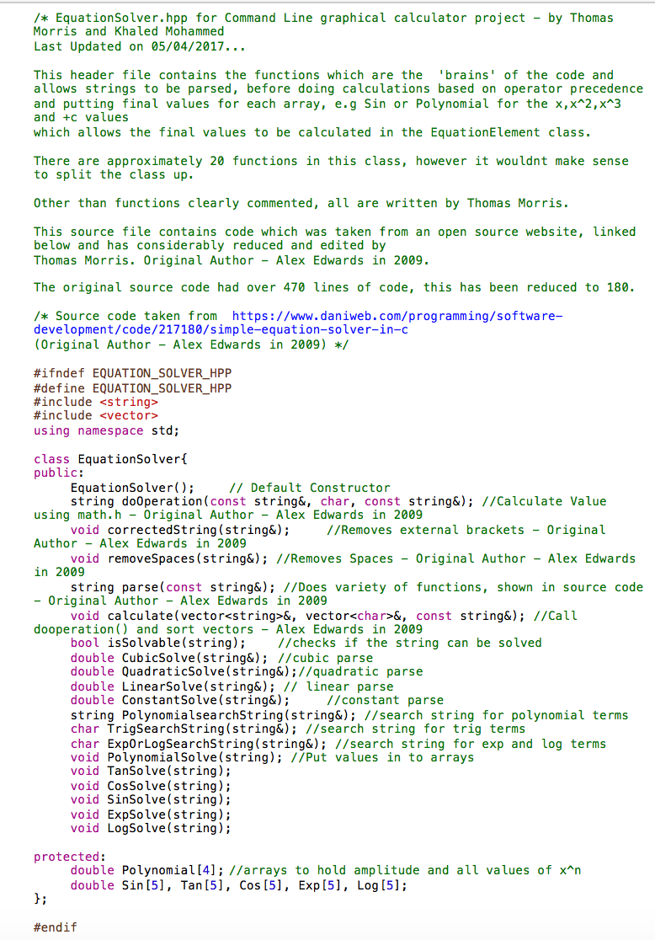

**Figure 1.** EquationSolver.hpp

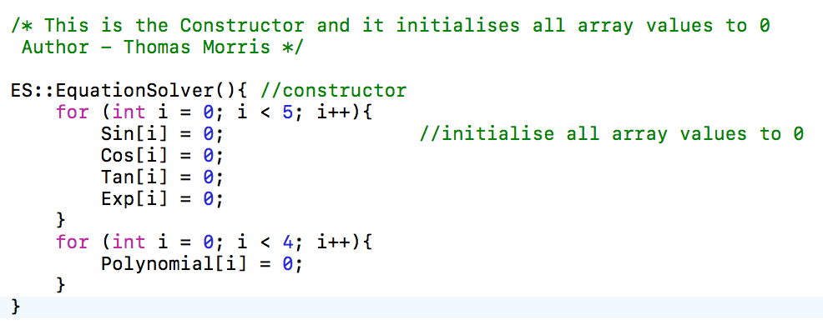

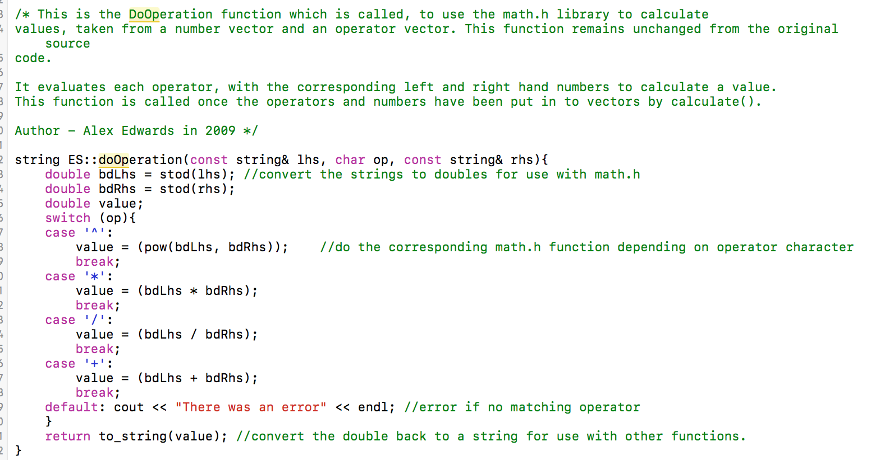**Figure 2.** Constructor

**Figure 3.** doOperation function

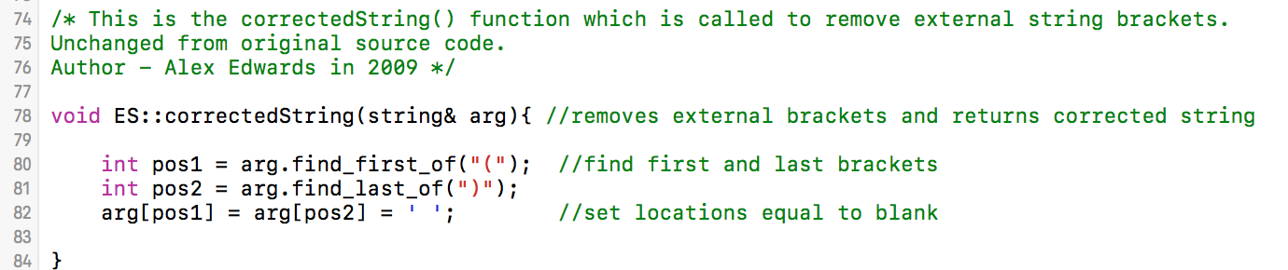

**Figure 4.** CorrectedString function

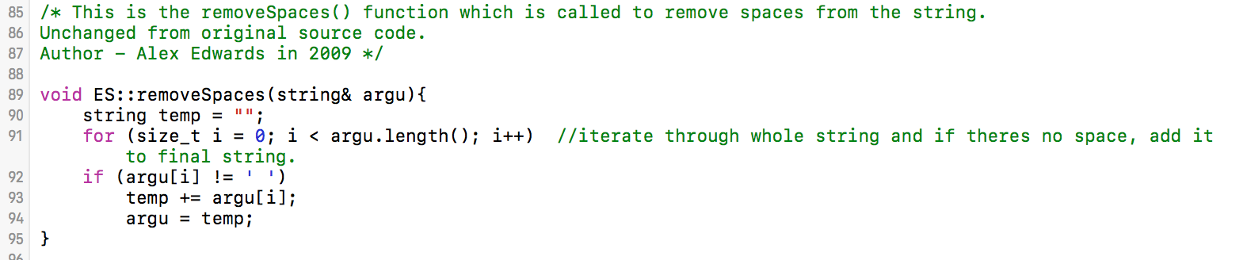**Figure 5.** RemoveSpaces function

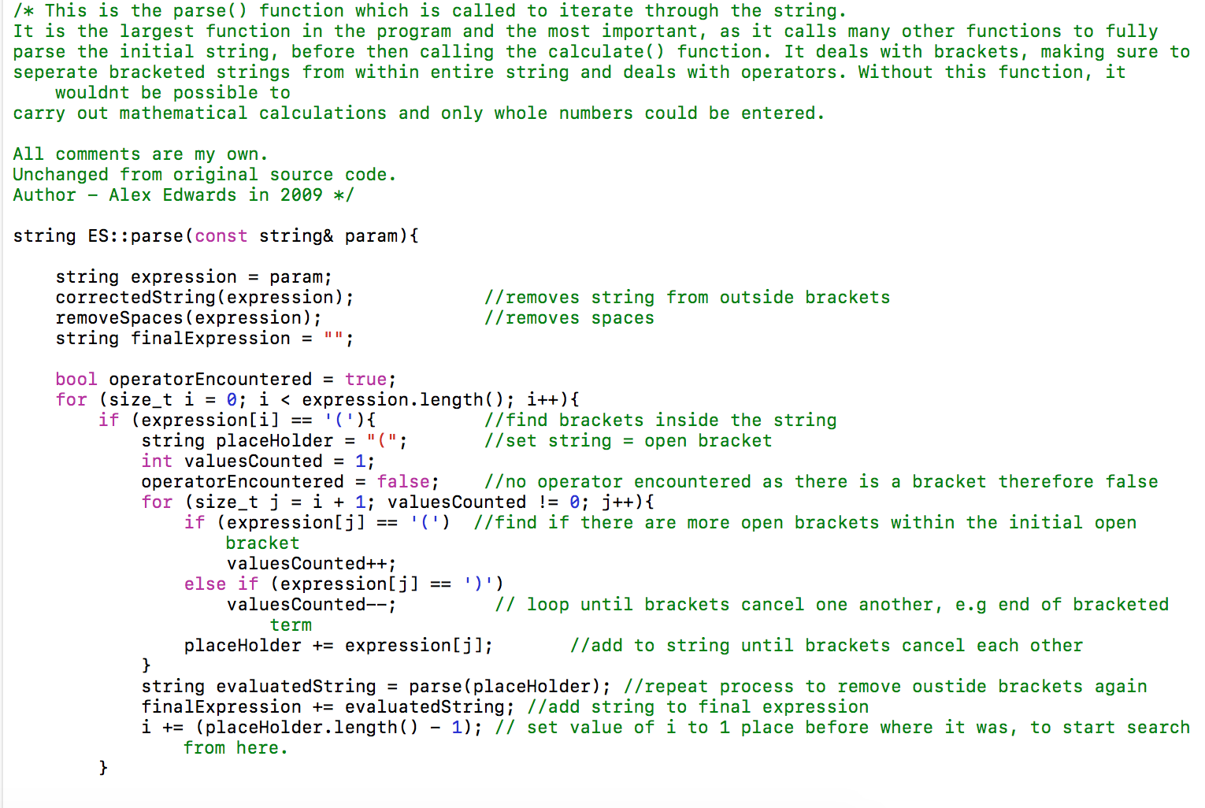

**Figure 6(a).** Parse function

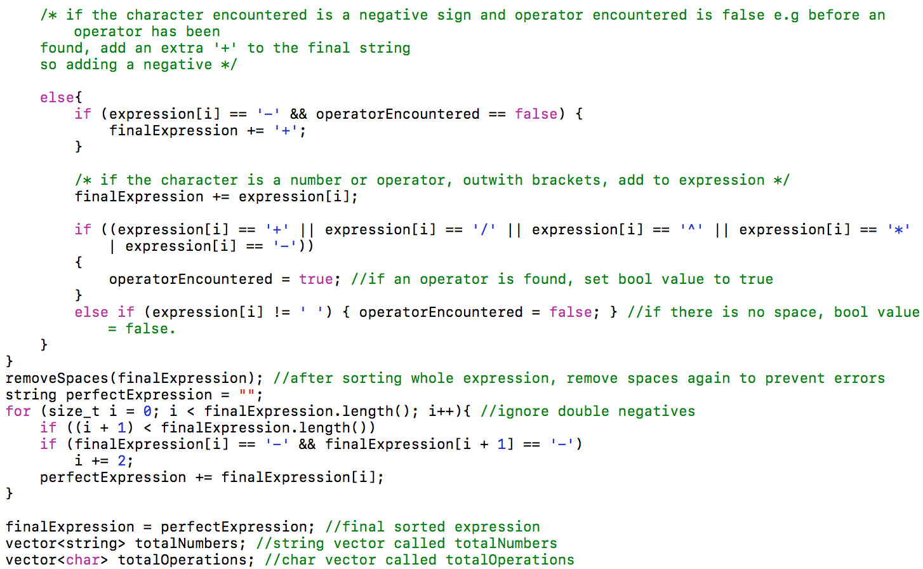

**Figure 6(b).** Parse function

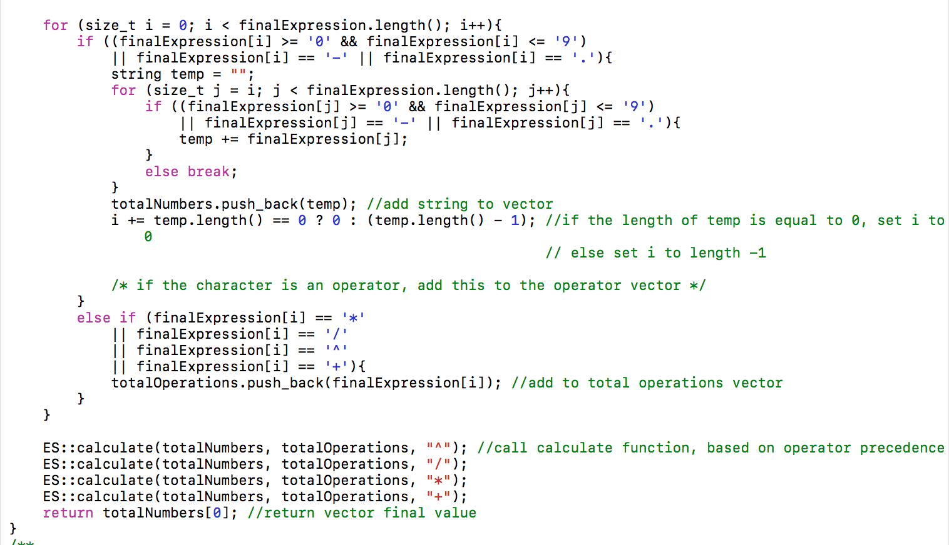

**Figure 6(c).** Parse function

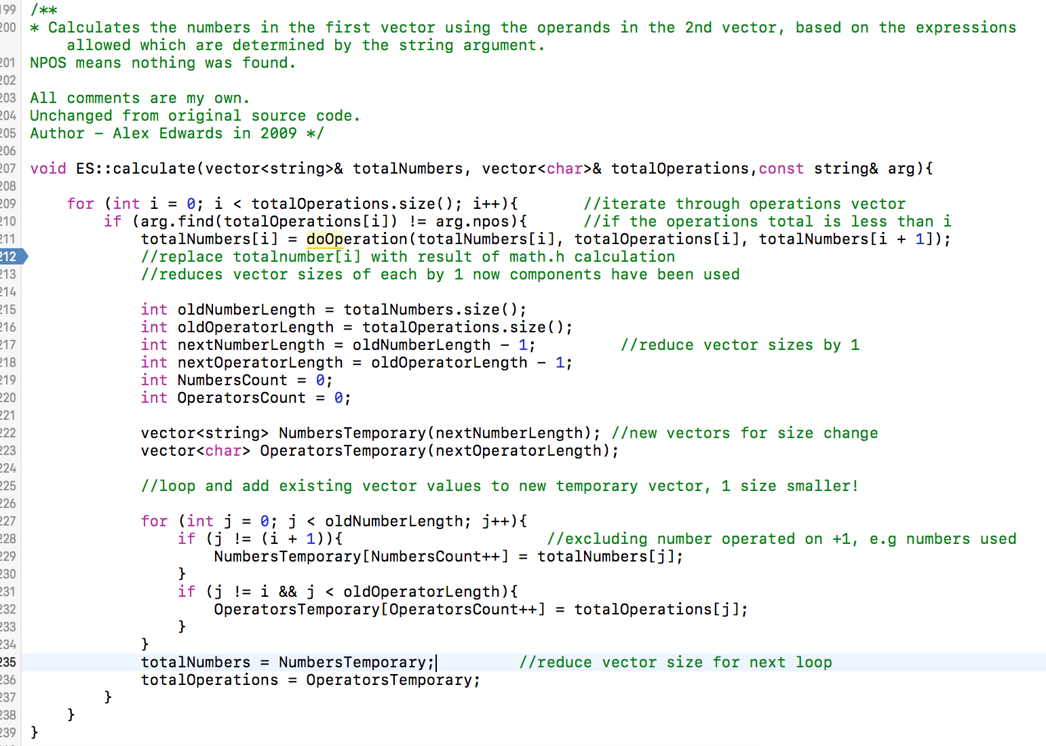

**Figure 7.** Calculate function

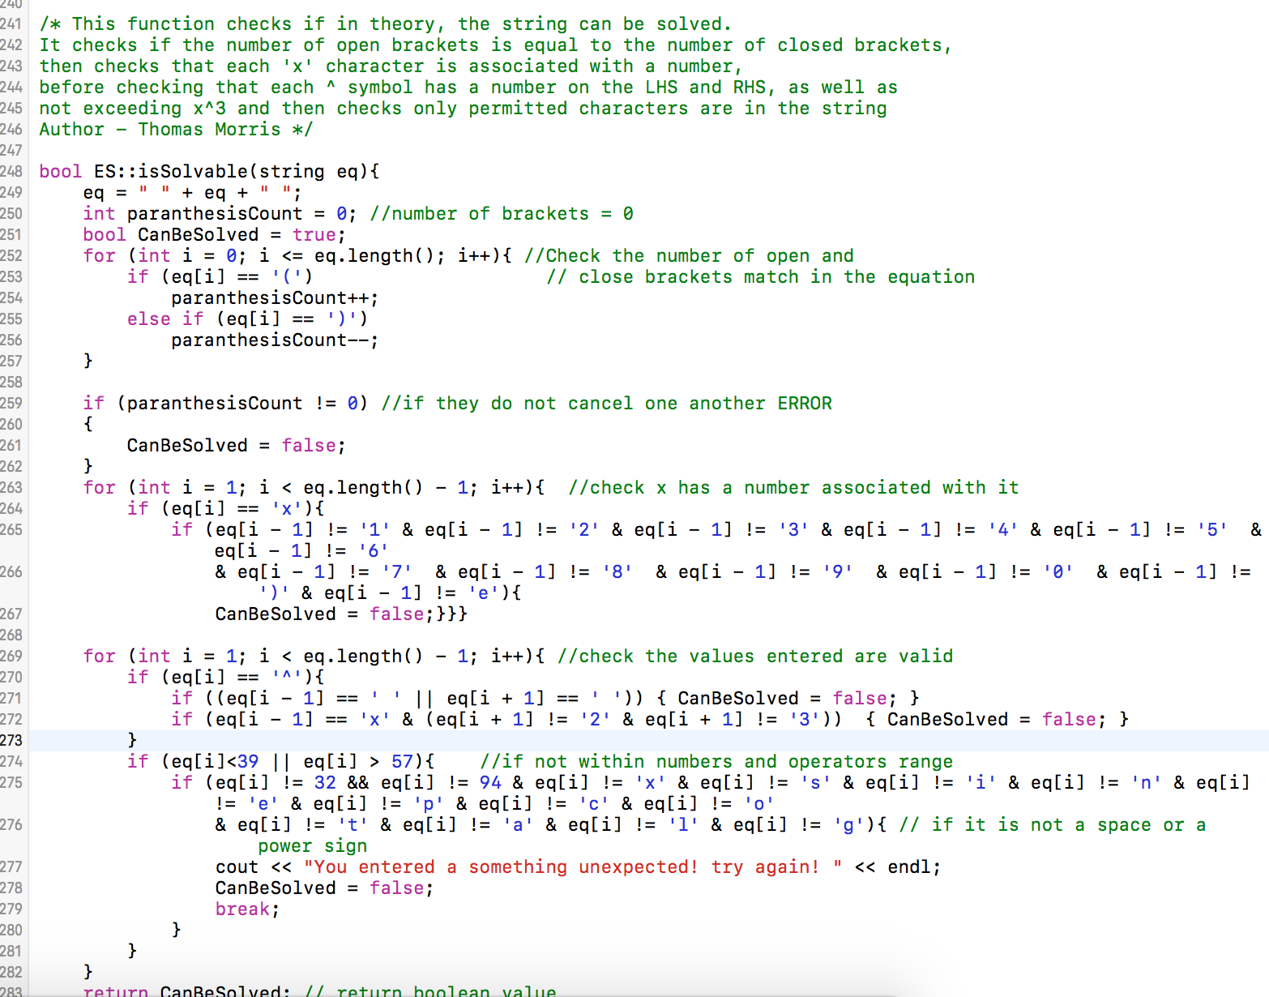

**Figure 8.** isSolvable function

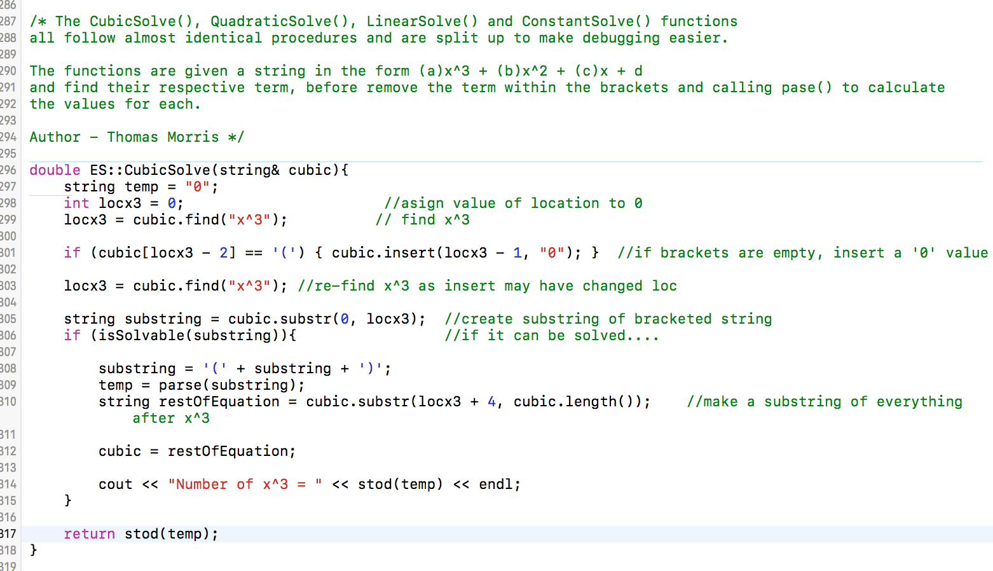

**Figure 9(a).** CubicSolve function

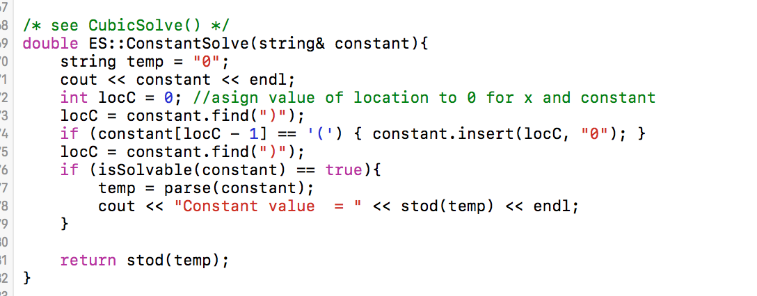

**Figure 9(b**) Constant Solve function

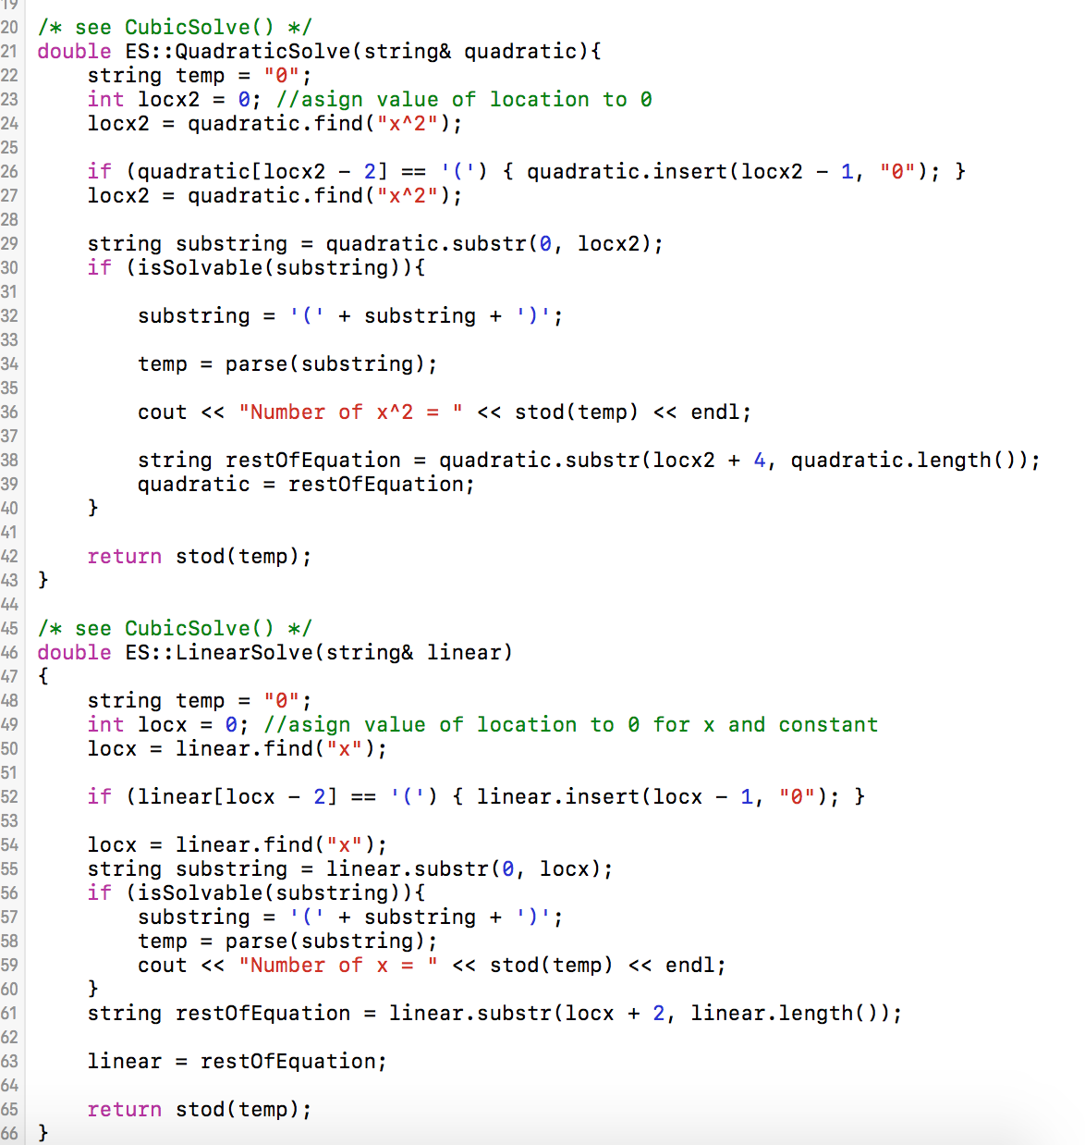

**Figure 9(c**) Quadratic and Linear Solve function

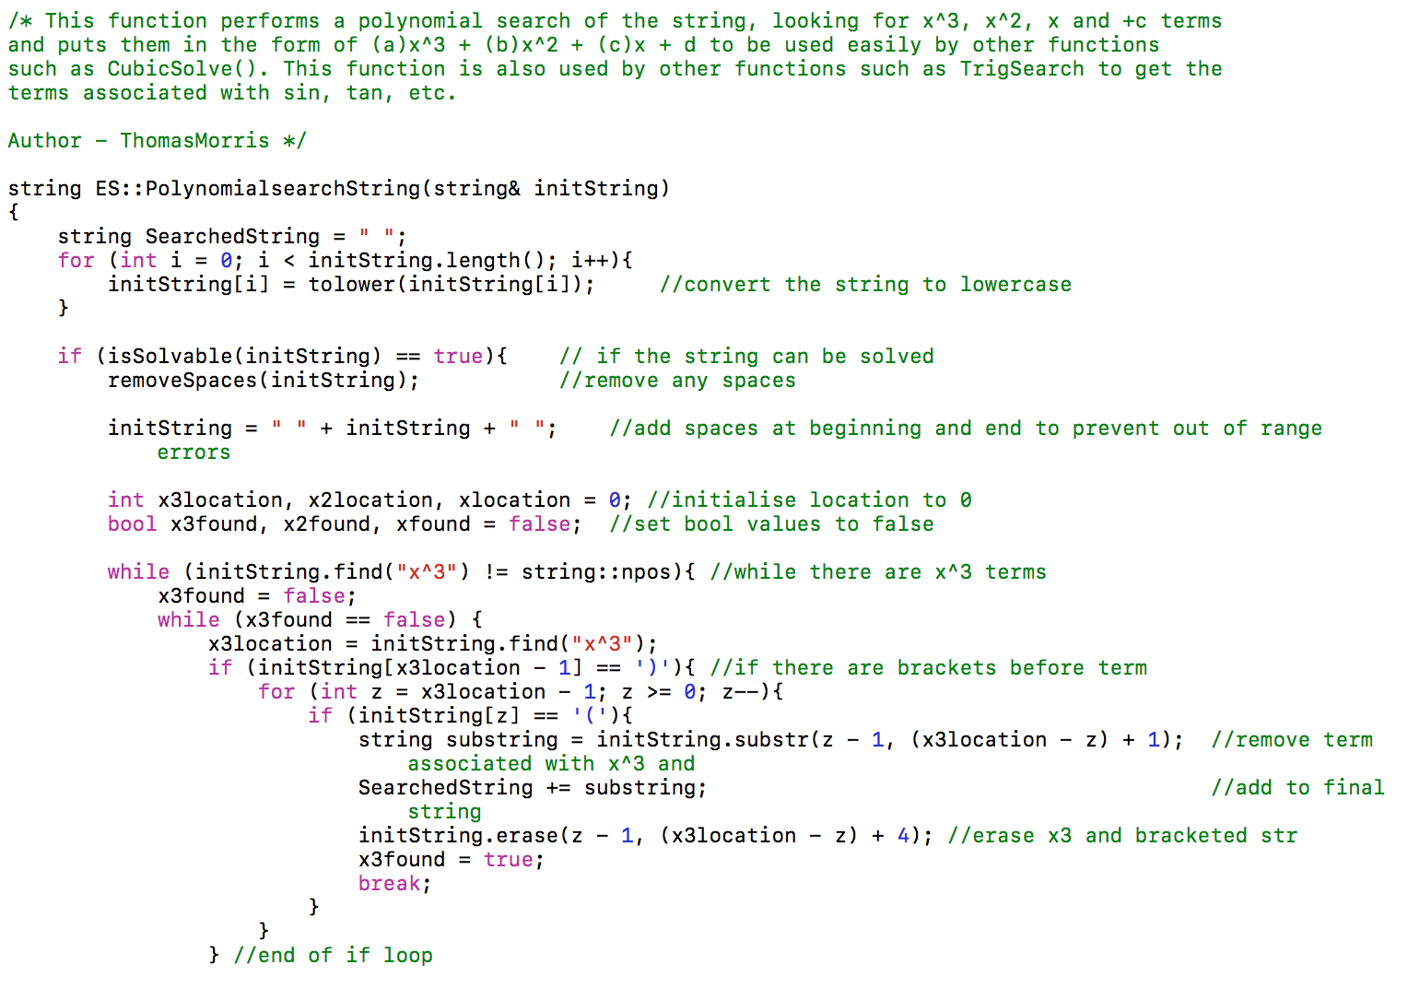

**Figure 10(a**) Polynomial Search Function

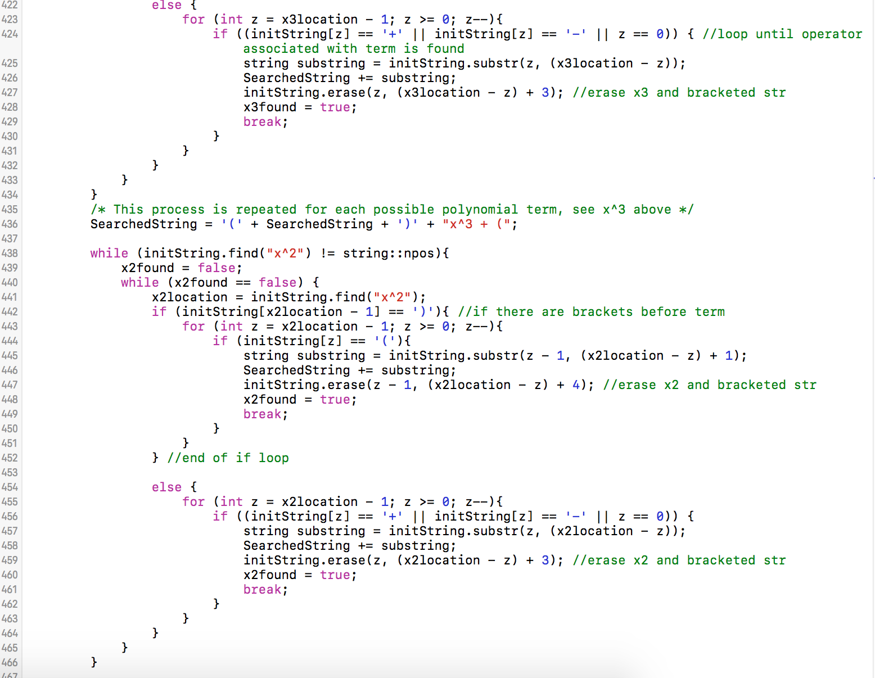

**Figure 10(b**) Polynomial Search Function

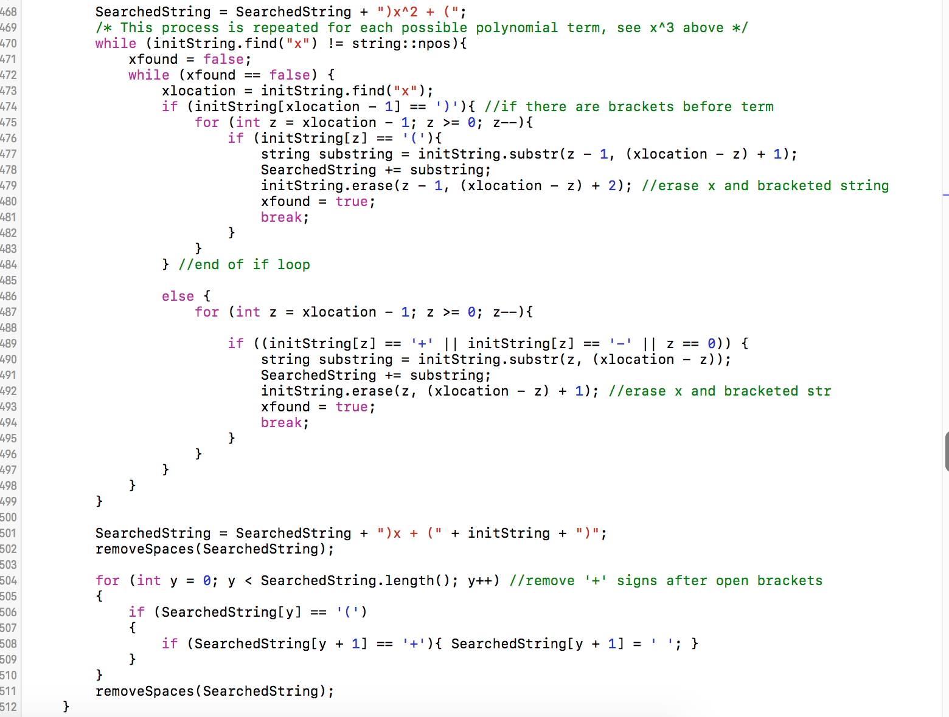

**Figure 10(c**) Polynomial Search Function

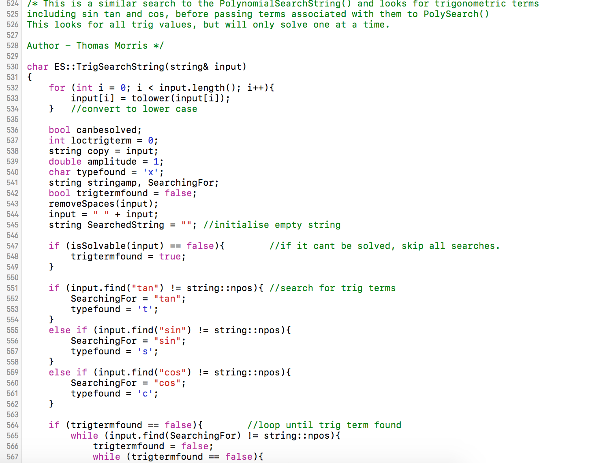

**Figure 10(d**) Trigonometric Search Function

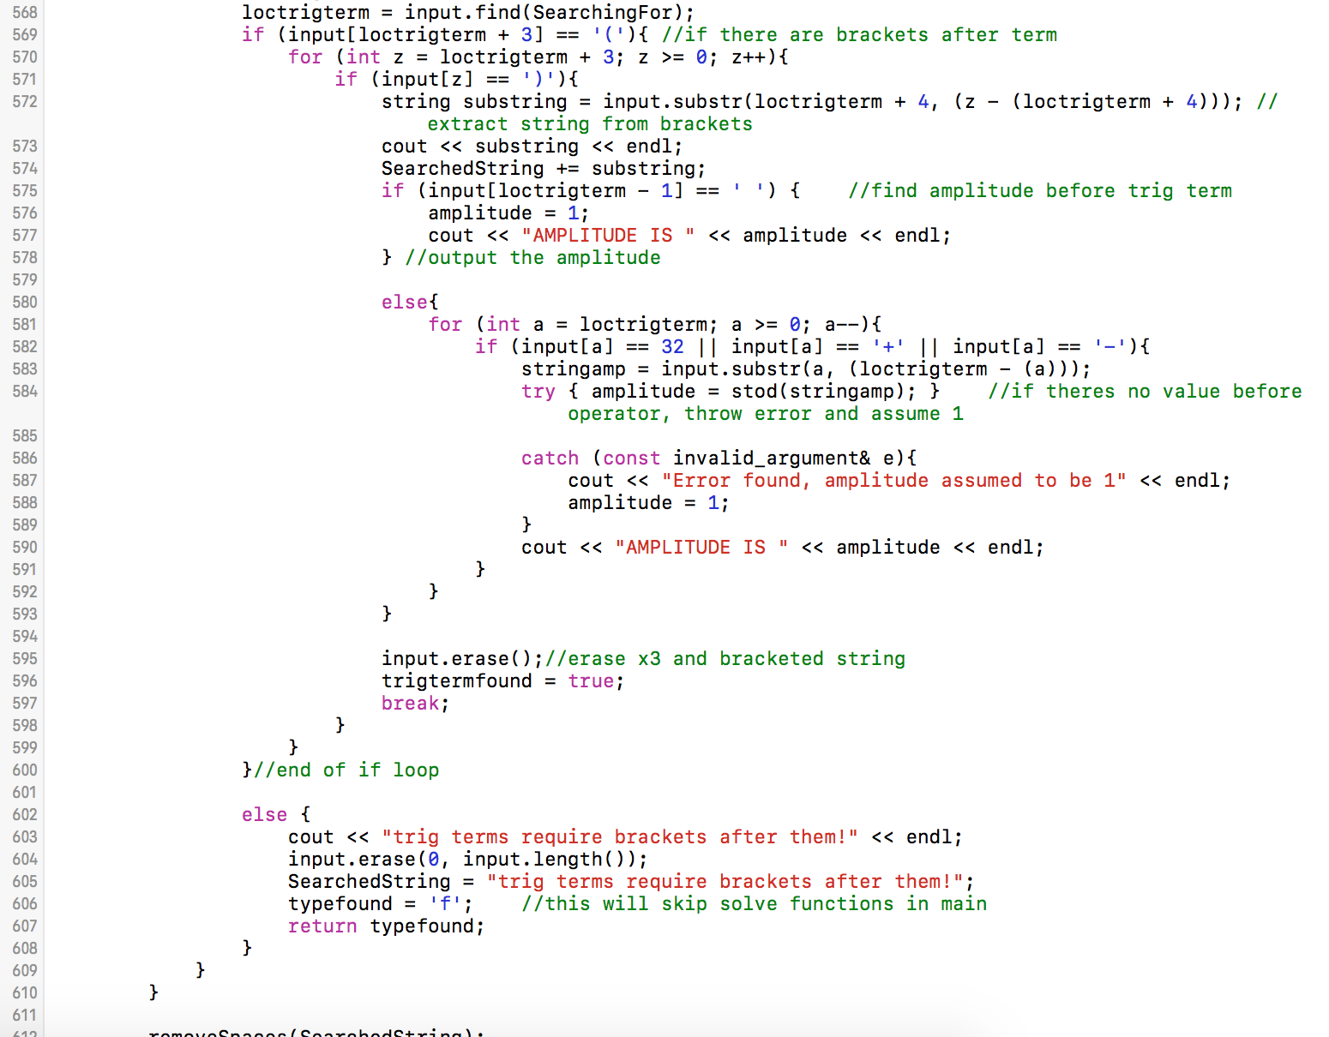

**Figure 10(e**) Trigonometric Search Function

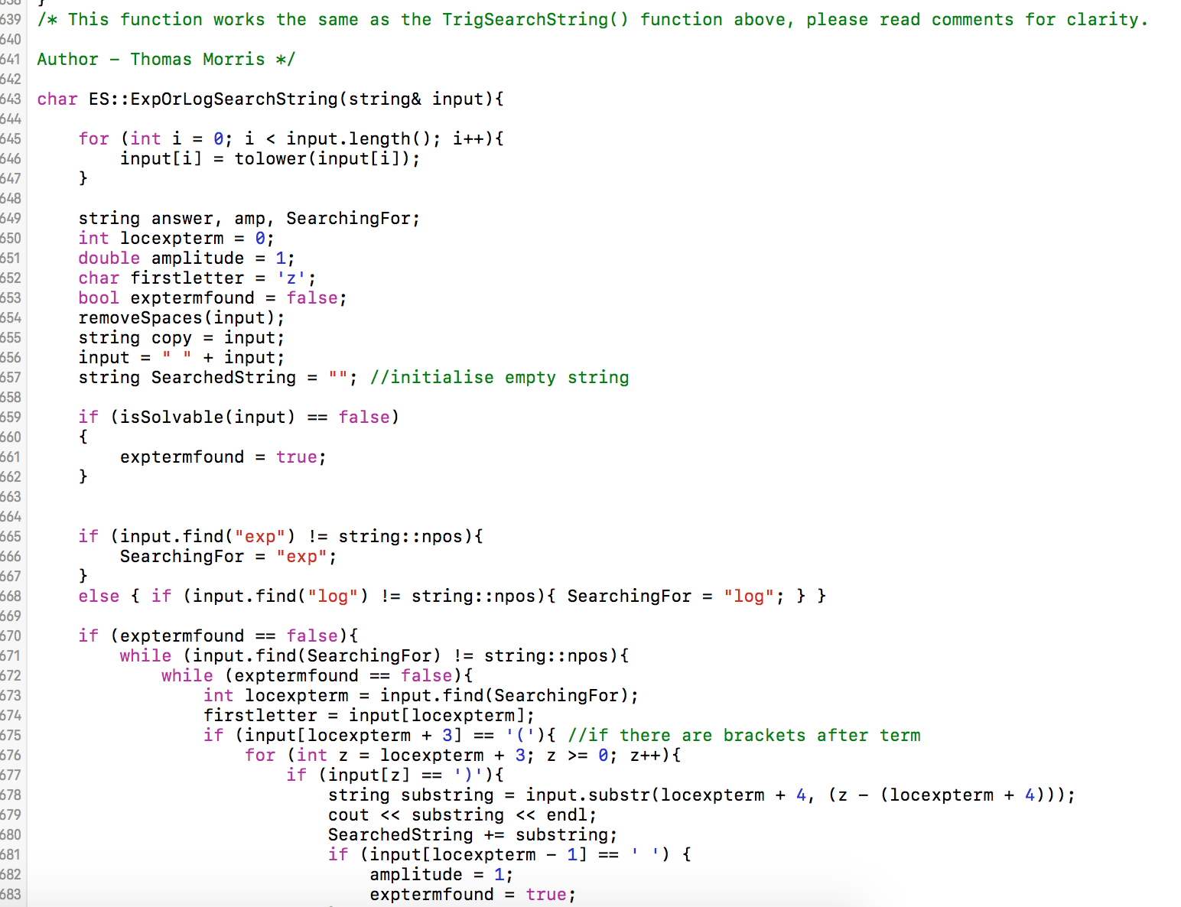

**Figure 10(f**) Exponential Search Function

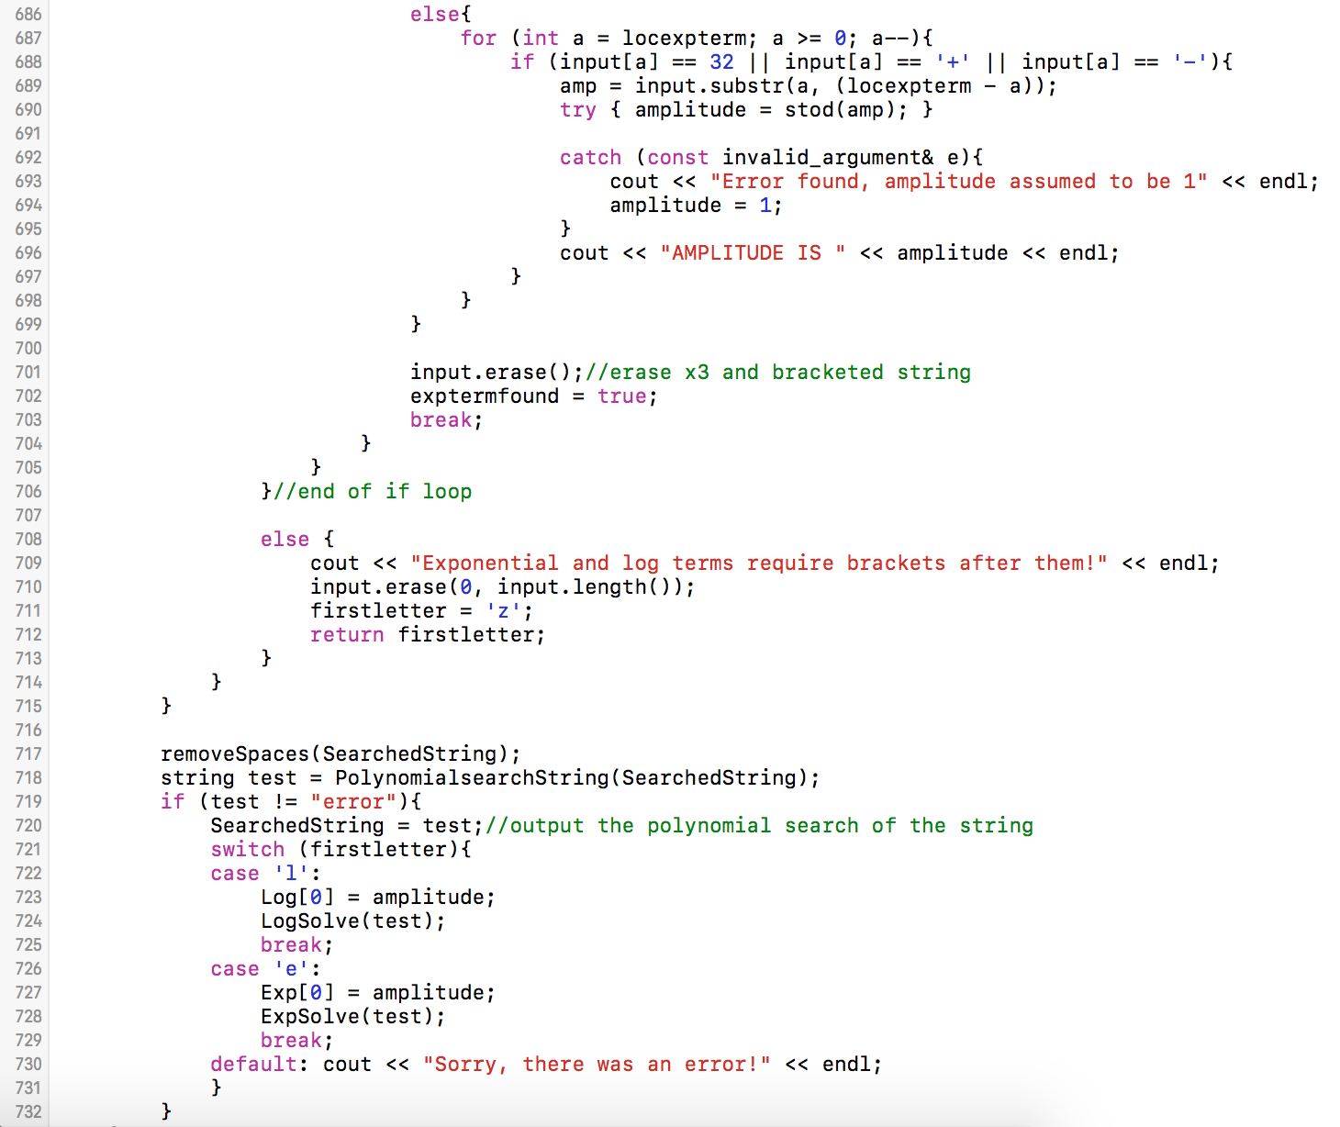

**Figure 10(g**) Exponential Search Function

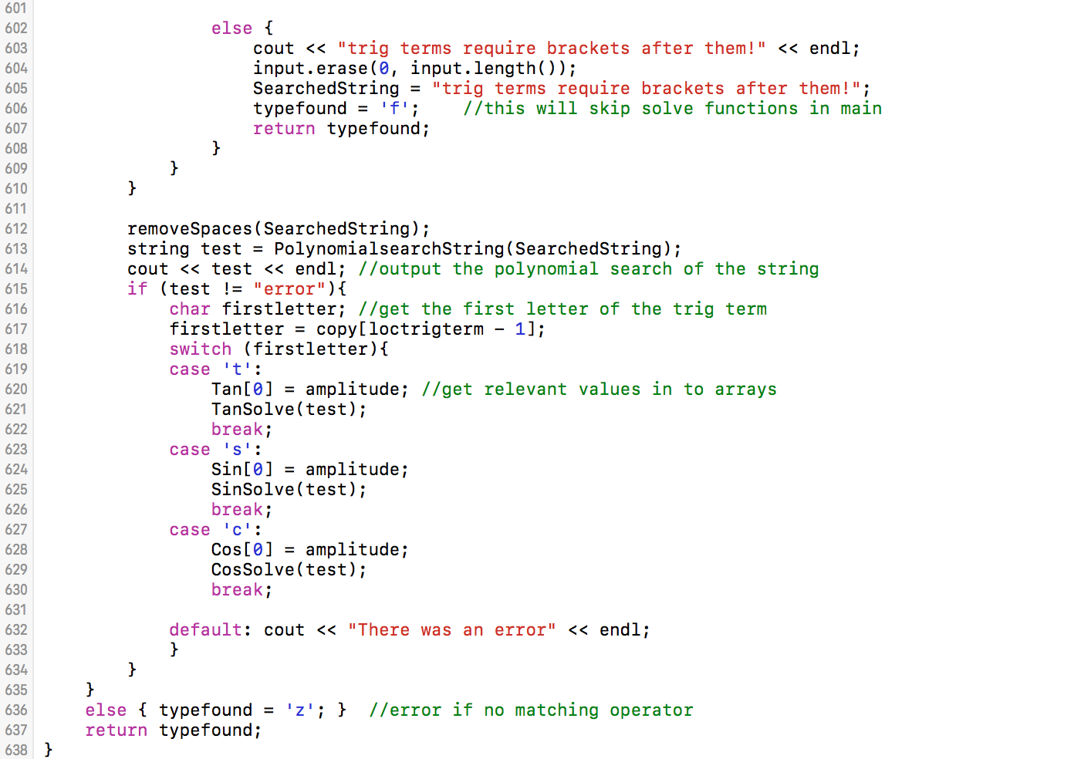

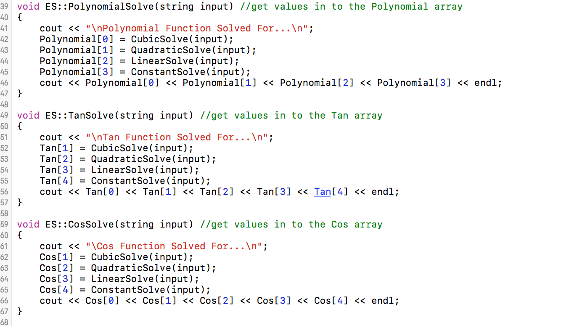**Figure 10(h**) Exponential Search Function

**Figure 11(a**) Polynomial, Tan and Cos Solve functions

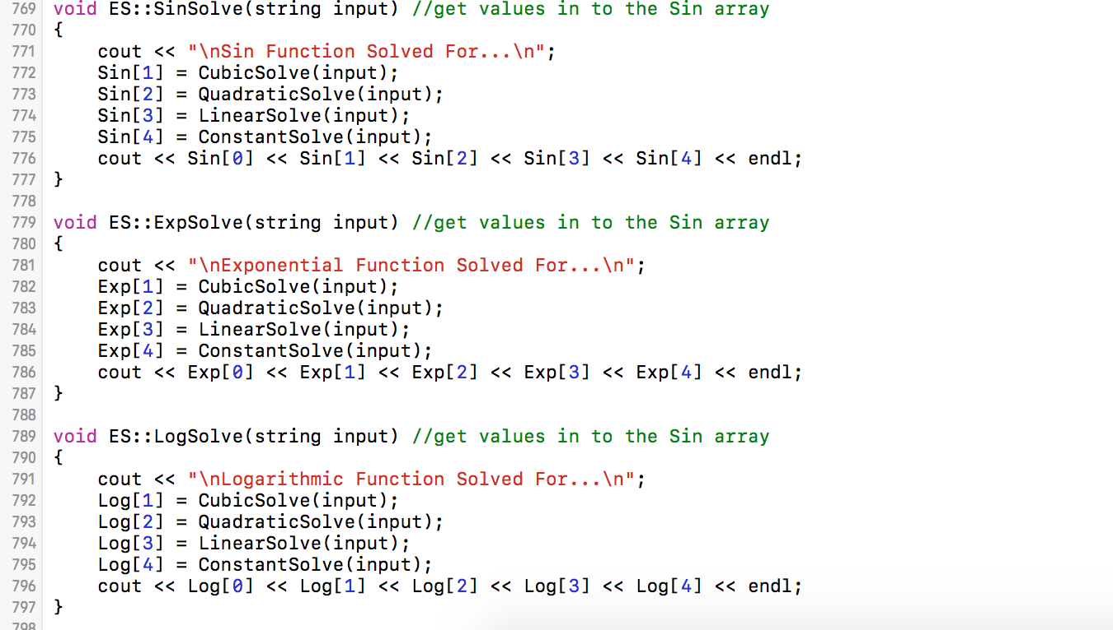

**Figure 11(b**) Polynomial, Tan and Cos Solve functions

# ../../../Desktop/Screen%20Shot%202017-04-10%20at%2010.06.Appendix B – EquationElement Class

**Figure 1.** Header file for EquationElement class

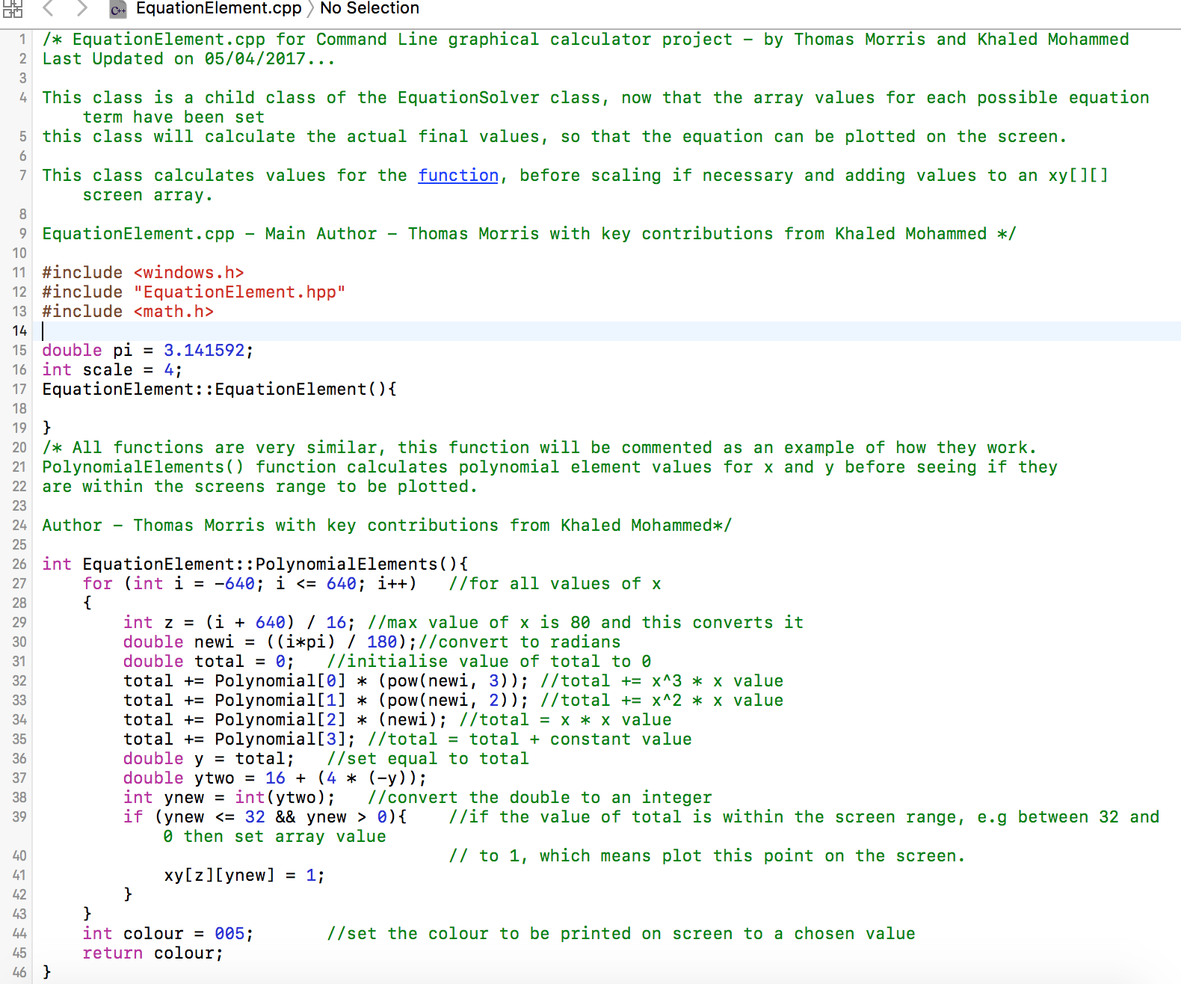

**Figure 2.** Source file for EquationElement class and Polynomial Function

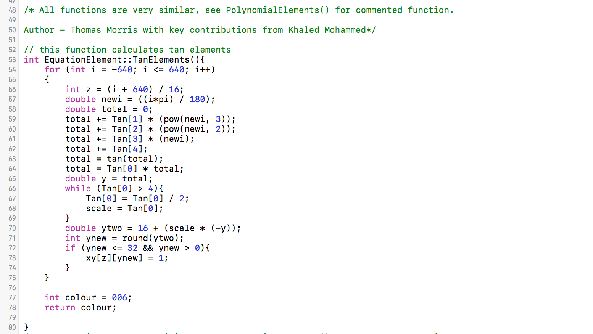

**Figure 3.** TanElements function

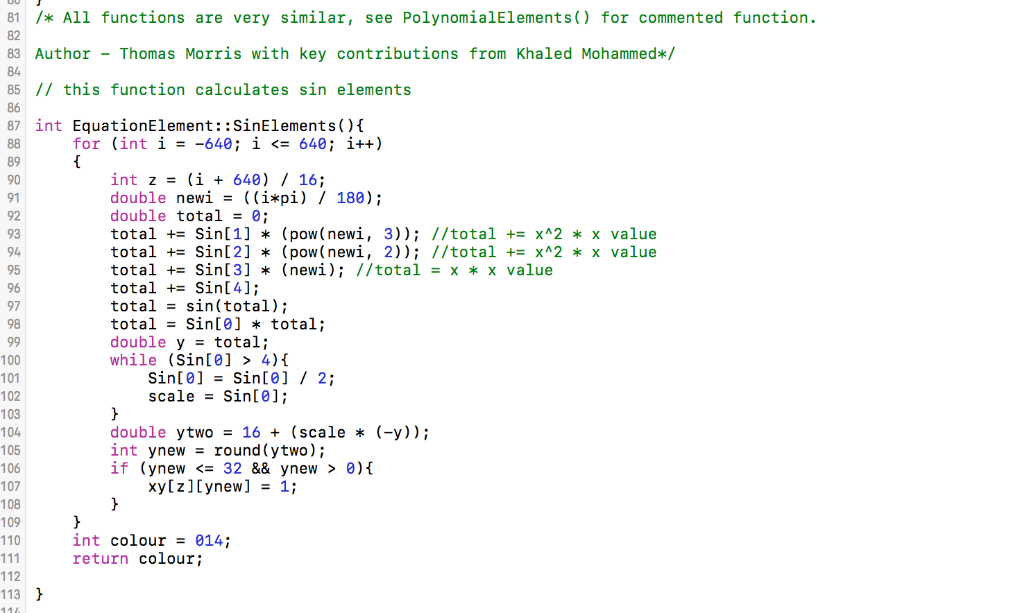

**Figure 4.** SinElements function

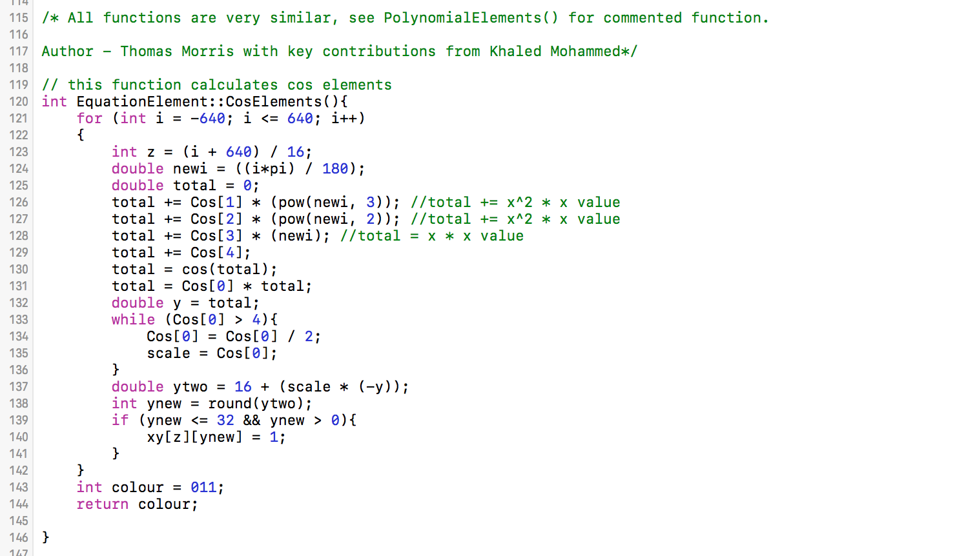

**Figure 5.** CosElements function

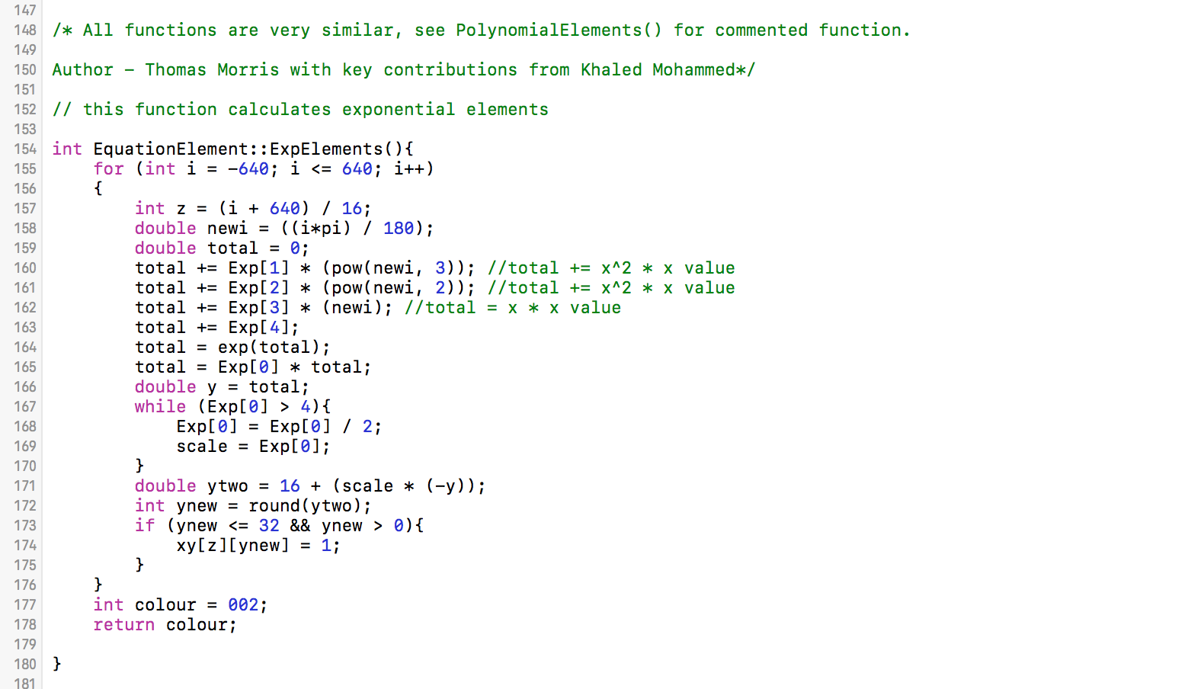

**Figure 6.** ExpElements function

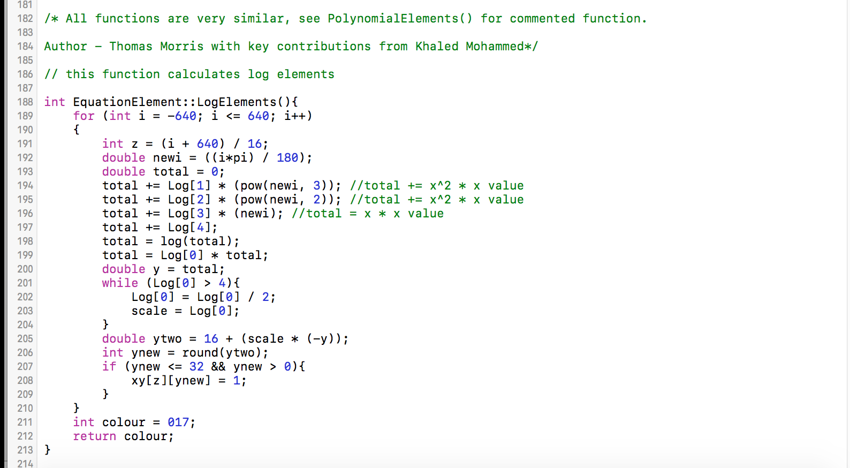

**Figure 7.** LogElements function

# ../../../Desktop/Screen%20Shot%202017-04-10%20at%2010.45.Appendix C – BarChart Class

**Figure 1.** DrawChart.hpp

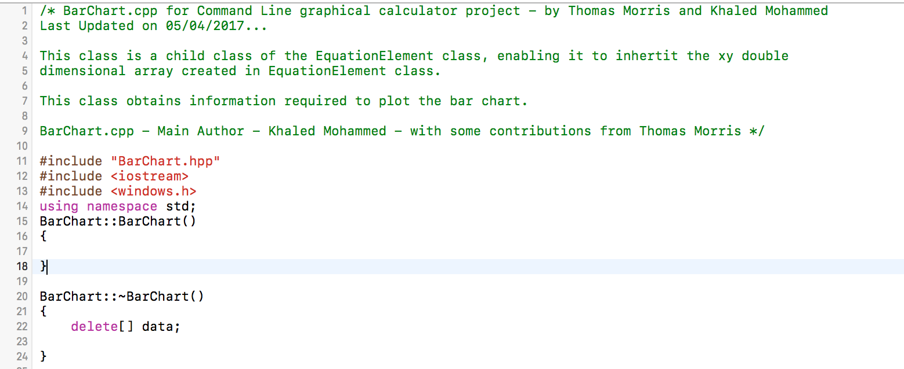

**Figure 2.** DrawChart.cpp showing constructor and destructor

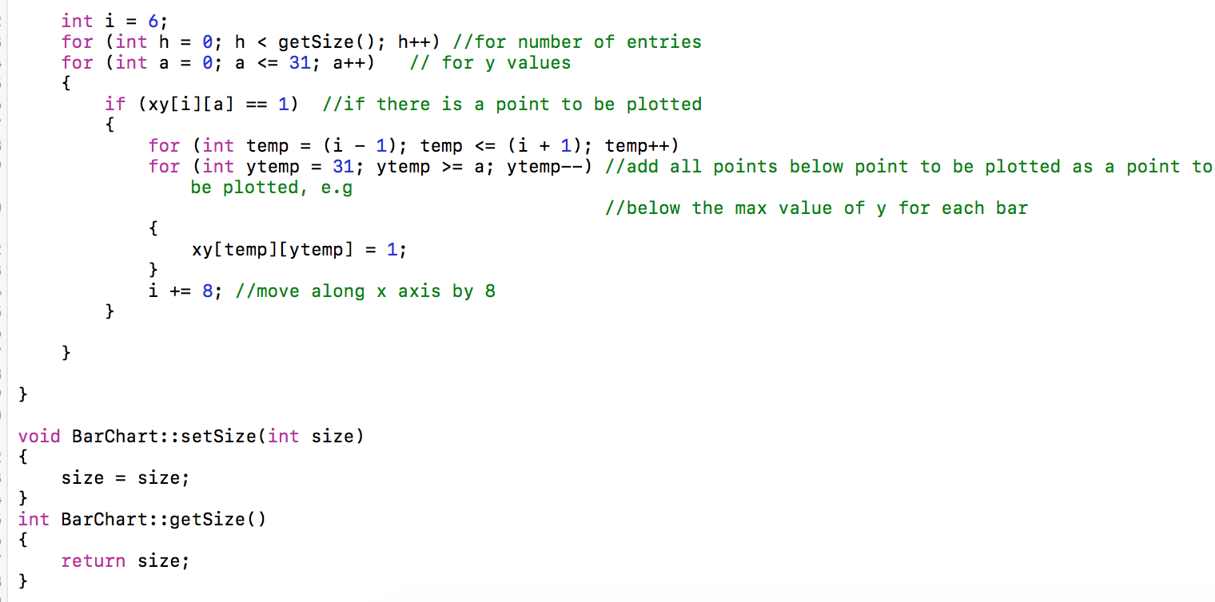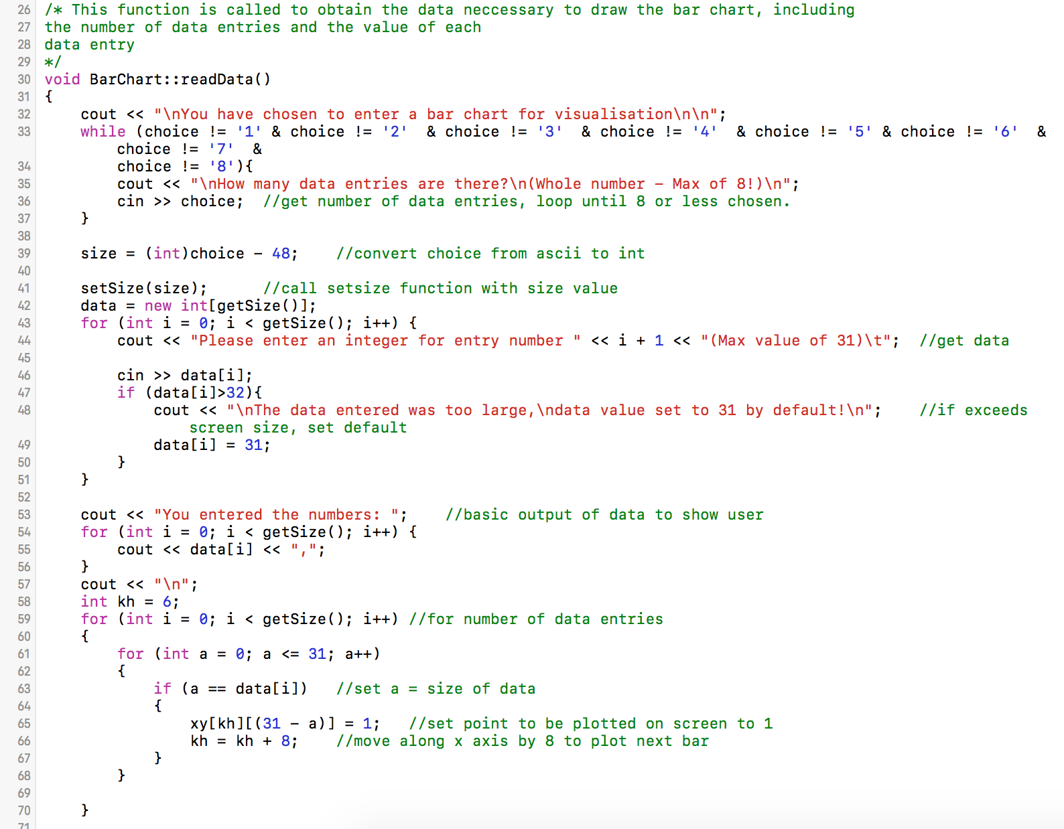

**Figure 3.** Functions within BarChart.cpp

# Appendix D – Draw Class

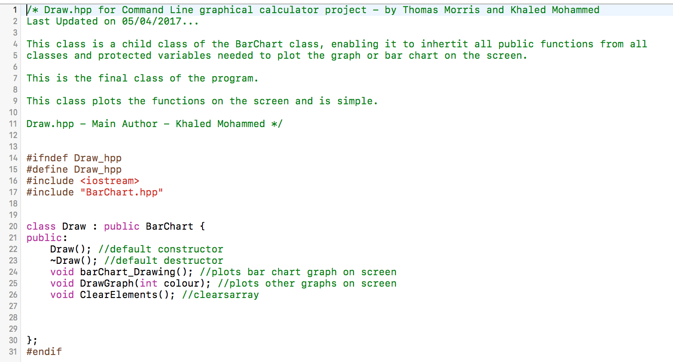

**Figure 1.** Draw.hpp

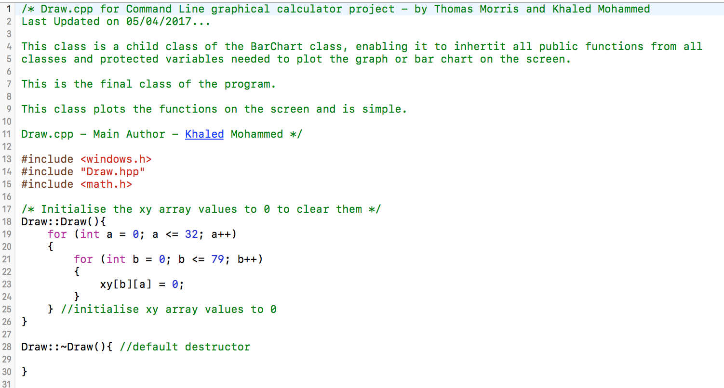

**Figure 2.** Draw.cpp

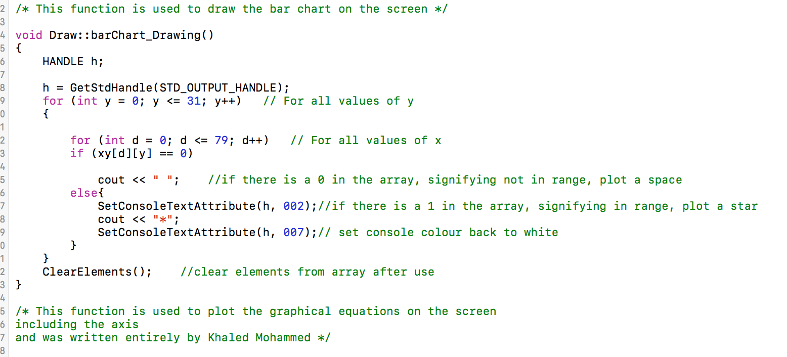

**Figure 3.** barChart drawing function

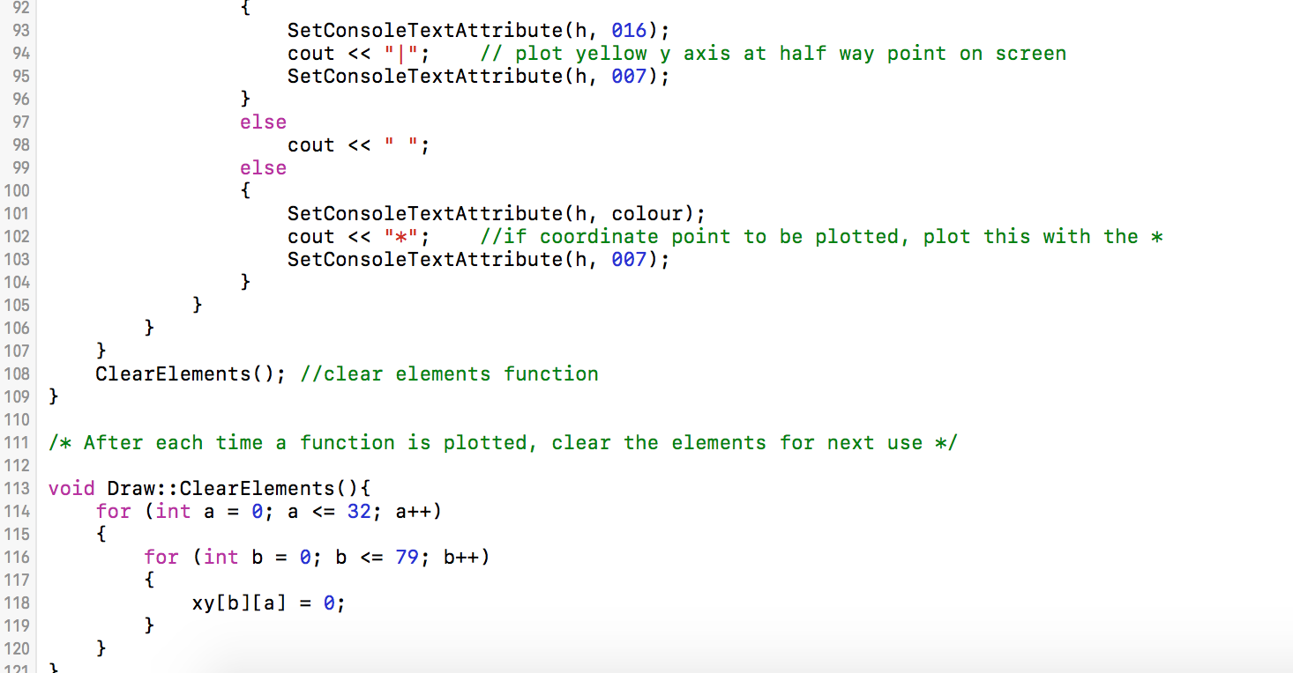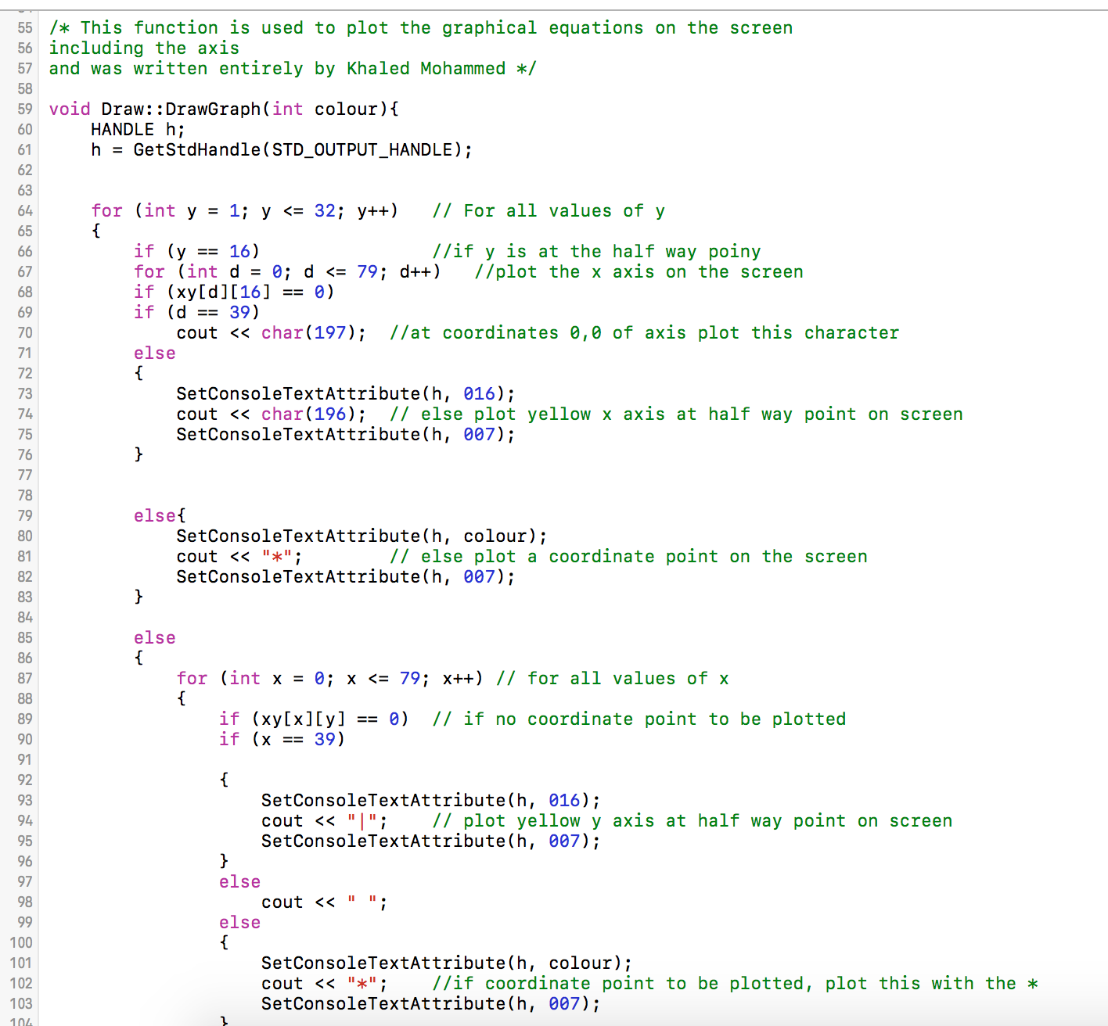**Figure 4.** Graph drawing function

**Figure 5.** Clear Elements function

# Appendix E

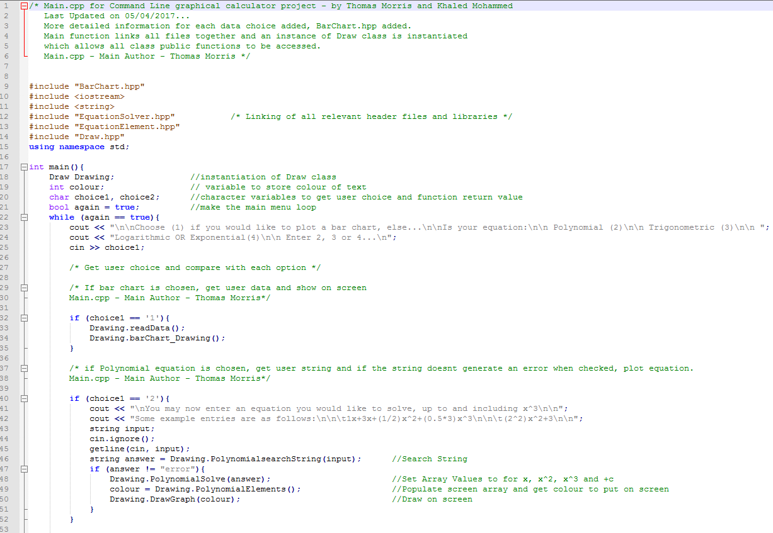

**Figure 1.** Main.cpp

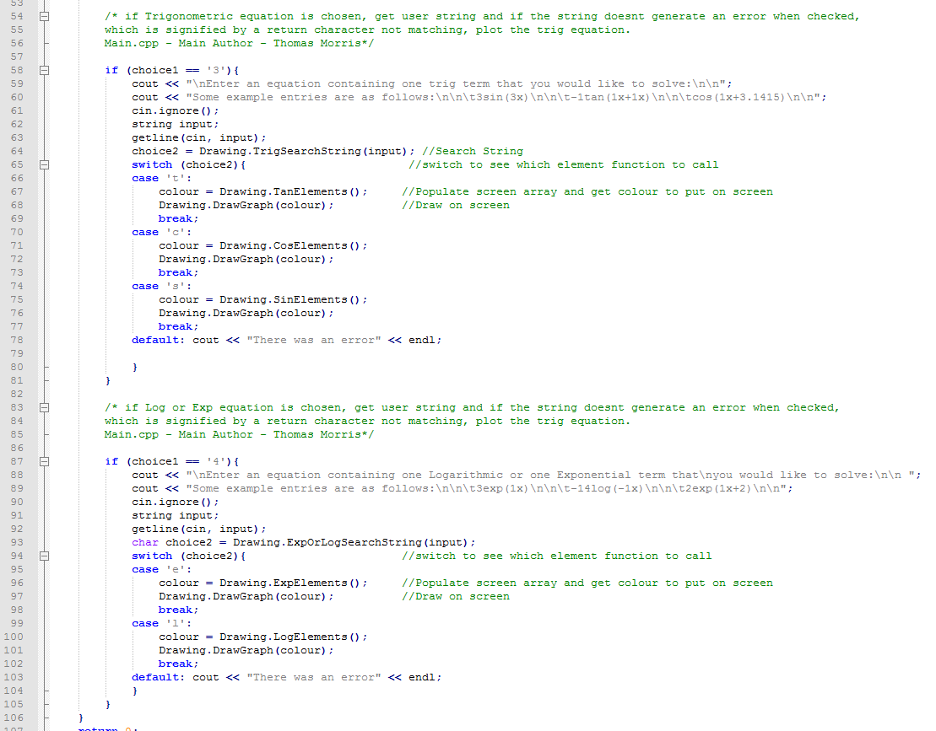**Figure 2.** Main.cpp

# Appendix F – Testing

|  |  |  |  |  |
| --- | --- | --- | --- | --- |
| **Name and ID of functionality under test** | **Step** | **Input** | | **Expected Result** |
| ***Sine function Test Cases*** |  |  | |  |
| Sine amplitude (#S001) | Zero Sine amplitude  Any fraction  Any large value  Amplitude as function of x within bracket | 0Sin(1x)  0.05Sin(1x)  1000Sin(1x)  (x+1)sin(2x)  x+1sin(2x) | | 1  1  1  1  1 |
| Sin angular velocity(#S002) | Angular velocity with phase shift  Zero angular velocity with phase shift  Zero angular velocity without phase shift | 3sin(1x^2+2x+3.1432)  3sin (0+3.1432)  3sin(0+0) | | 1  1  1 |
| Sine phase shift(#S002) | Phase shift by zero  Phase shift by PI  Phase shift by 10 PI | 2sin(2x+0)  2sin(2x+3.14325)  2sin(2x+31.4325) | | 1  1  1 |
| Sine string parse (#S003) | If amplitude missed  If bracket is unclosed  If bracket is unopened  If any capital latter’s  If any space  If any other characters | sin(4x^3+3.14325)  sin(4x^3+3.14325  sin 4x^3+3.14325)  siN(4x^3+3.14325)  sin(4x^3+ 3.143)  sin(4x^3+3.1&325) | | 1  1  1  1  1  1 |
| Sine when it has polynomial with higher than degree 3 argument(#S004) | Polynomial higher than degree 3  Polynomial when has zero degree | 2sin(x^5)  2sin(x^0) | | 1  1 |
| Sin when it has constant argument (#S005) | When there is only phase | Sin(1.5707) | | 1 |
| Sine when has zero argument(#S006) | Sin with zero argument | Sin(0) | | 1 |
| ***Cosine function Test cases*** |  |  | |  |
| cos amplitude (#C001) | Zero Sine amplitude  Any fraction  Any large value  Amplitude as function of x with in bracket | 0cos(1x)  0.05cos(1x)  1000cos(1x)  (x+1)cos(2x) | | 1  1  1  1 |
| cos angular velocity(#C002) | Angular velocity with phase shift  Zero angular velocity with phase shift  Zero angular velocity without phase shift | 3cos(1x^2+2x+3.1432)  3cos(0+3.1432)  3cos(0+0) | | 1  1  1 |
| cos phase shift(#C003) | Phase shift by zero  Phase shift by PI  Phase shift by 10 PI | 2cos(2x+0)  2cos(2x+3.14325)  2cos(2x+31.4325) | | 1  1  1 |
| cos string parse (#C004) | If amplitude missed  If bracket is unclosed  If bracket is unopened  If any capital latter’s  If any space  If any other characters | cos(4x^3+3.14325)  cos(4x^3+3.14325  cos 4x+3.14325)  coS(4x+3.14325)  cos(4x+ 3.143)  cos(4x+3.1&325) | | 1  1  1  1  1  1 |
| Cos when has polynomial with higher than degree 3 argument(#C004) | Polynomial higher than degree 3  Polynomial when has zero degree | 2cos(x^5)  2cos(x^0) | | 1  1 |
| cos when has constant argument (#C005) | When there is only phase | Cos(0.7853) | | 1 |
| cos when has zero argument(#C006) | Cos at zero | cos(0) | | 1 |
| ***Tangent function Test cases*** |  |  | |  |
| tan amplitude (#T001) | Zero Sine amplitude  Any fraction  Any large value  Amplitude as function of x with in bracket | 0tan(1x)  0.05tan(1x)  1000tan(1x)  (x+1)tan(2x) | | 1  1  1  1 |
| tan angular velocity(#T002) | Angular velocity with phase shift  Zero angular velocity with phase shift  Zero angular velocity without phase shift | 3tan(1x^2+2x+3.1432)  3tan(0+3.1432)  3tan(0+0) | | 1  1  1 |
| tan phase shift(#T003) | Phase shift by zero  Phase shift by PI  Phase shift by 10 PI | 2tan(2x+0)  2tan(2x+3.14325)  2tan(2x+31.4325) | | 1  1  1 |
| tan string parse (#T004) | If amplitude missed  If bracket is unclosed  If bracket is unopened  If any capital letters  If any space  If any other characters | tan(4x^3+3.14325)  tan(4x^3+3.14325  tan4x^3+3.14325)  taN(1x+3.14325)  tan(1x+ 3.143)  tan(1x+3.1&325) | | 1  1  1  1  1  1 |
| when has polynomial with higher than degree 3 argument(#T005) | Polynomial higher than degree 3  Polynomial when has zero degree | 2tan(x^5)  2tan(x^0) | | 1  1 |
| Tan when has constant argument (#T006) | When there is only phase | Tan(1.5707) | | 1 |
| tan when has zero argument(#T007) | Tan at zero | tan(0) | | 1 |
| **Name and ID** | **Step** | **Input** |  | **Expected Result** |
| Polynomial with degree (#P001) | Degree higher than 3  Degree is fraction(hyperbola)  Degree zero | 1x^6  1x^0.5  1x^0 | | 1  1  1 |
| Polynomial with different coefficient (very large or small) (#P002) | Very large coefficient  Very small coefficient  Zero coefficient  Coefficient within bracket  Empty coefficient  Coefficient in term of x inside bracket  Coefficient in term of x without bracket | 1000x^2  .05x^2  0x^3  (5)x^2+(2)x  1x+3  (x^2+1)x^3  2xx^3+4 | | 1  1  1  1  1  1  1 |
| Polynomial only constant(#P003) | If it’s only constant function | 3  (1+2) | | 1  1 |
| Polynomial sting format (#P004) | If bracket is unclosed  If bracket is unopened  If any capital letters  If any space  If any other characters  Without bracket | 3x^2+(3x  2x^2+3)  1X^2-2  1x+ 3.  1x+31&5  X^3+3 | | 1  1  1  1  1  1 |

**Bar chart test cases**

|  |  |  |
| --- | --- | --- |
| **Name and ID** | **Step** | **Expected Result** |
| Number of data present range (#B001) | If it’s more than 8  If its zero data  If its decimal points  If its other characters  if its between 1 and 8 | 1  1  1  1  1 |
| Maximum height (#B002) | If it’s more than 31  If its zero height  If its decimal points  If its other characters  if its between 1 and 31 | 1  1  1  1  1 |

**Logarithm and exponential test cases**

|  |  |  |
| --- | --- | --- |
| **Name and ID** | **Step** | **Expected Result** |
| Logarithm  (#P001) | Log zero (undefined)  Log negative (undefined)  Log with polynomial argument  Log with special characters  Log open bracket  Expected format | 1  1  1  1  1  1 |
| Exponential  (#E001) | Exponent of function of x  Exponent of constant base  Exponent of base any other character | 1  1  1 |

# Appendix G – User Guide

**Project S: Command Line Graphical Calculator - User Guide**

**System Requirements:**

The required OS is Microsoft Windows, with MS Visual Studio 2013 or a more up to date version of this software installed.

**Running the Program:**

Once the program has been downloaded and loaded using MS VS it must be compiled and then, the program should be run, without debugging, however it may be run with debugging if you choose, it makes no difference to the overall functionality of the program.

**Using the Program:**

The program is very simple to use. A basic menu is given each time the user is able to choose which type of data representation they would like. The user should enter ‘1’ if they would like to plot a bar chart, ‘2’ if they would like to solve and visualise a polynomial function, e.g a function containing purely xn terms, , ‘3’ if they would like to solve and visualise a trigonmetric function, e.g a function containing a singular trigonmetric term and ‘4’ if they would like to solve and visualise a function containing either exponential or logarithmic terms.

*If ‘1’ is chosen:*

If the user chooses to represent data as a bar chart, the program will then ask the user to choose the number of data entries. The user should enter an integer which is less than 9, as the maximum number of data entries is 8.

The user will then be prompted to enter the amplitude for each data entry in ascending order and this data should be entered as an integer which is less than 32, as the maximum value for any data entry is 32.

The program will then display the bar chart and return to the main menu, awaiting user input.

*If ‘2’ is chosen:*

The user will be shown an example of how to enter a polynomial function. Each function must not contain terms greater than x4 and the expression should not contain anything except operators, numbers and powers of xn. Each value of x must have a number associated wih it, e.g. ‘3+x’ will return an error, the function must read ‘3+1x’. The program does not currently evaluate operations of xn, e.g. 1x^2*2x^2 would equal 2x^2 and not 2x^4.

The user may enter numbers within the range +/- 1.7e +/- 308, the c++ double type range.

An example entry is: (1+3x+0.5x^2+(1/2)x^3)

The program will then display the graph and return to the main menu, awaiting user input.

*If ‘3’ is chosen:*

The user will be shown an example of how to enter a trigonometric function. Each function must not contain terms greater than x4 and the expression should not contain anything except operators, numbers and powers of xn. Each value of x must have a number associated wih it, e.g. ‘3+x’ will return an error, the function must read ‘3+1x’. The trigonometric term must have brackets associated with it and the user has the option to choose an amplitude for the function. The user may enter equations containing a single ‘cos’, ‘sin’ or ‘tan’ term. Some example entries are as follows:

7tan(3x+2)

-1sin(1x^2)

The user may enter numbers within the range +/- 1.7e +/- 308, the c++ double type range.

The program will then display the graph and return to the main menu, awaiting user input.

*If ‘4’ is chosen:*

The user will be shown an example of how to enter an exponential or logarithmic function. Each function must not contain terms greater than x4 and the expression should not contain anything except operators, numbers and powers of xn. Each value of x must have a number associated wih it, e.g. ‘3+x’ will return an error, the function must read ‘3+1x’. The exponential or logarithmic term must have brackets associated with it and the user has the option to choose an amplitude for the function. The user may enter equations containing a single ‘exp’ or ‘log’ term. Some example entries are as follows:

7log(3x+2)

-1exp(1x^2)

The user may enter numbers within the range +/- 1.7e +/- 308, the c++ double type range.

The program will then display the graph and return to the main menu, awaiting user input.

**Operator Precedence:**

The program will evalute functions using the BODMAS system. Brackets, followed by division, multiplication, addition and finally subtraction.

**Preventing Errors:**

To prevent errors, follow the rules and guidelines given within each choice section. Most unexpected inputs will return an error and the user will be given the main menu choice again. If the program generates any other errors, it should be stopped and re-run. Common sense should be used when entering expressions to be evaluated.